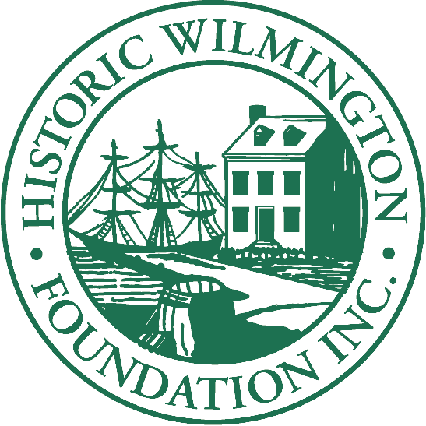

THE IMPACT OF PRESERVATION
2021 High School Scholarship Contest
Thursday, October 7, 2021

General Information:
The purpose of the Historic Wilmington Foundation, Inc., High School Scholarship Program: “The Impact of Preservation Contest” is to provide participants and audience members education and appreciation about our region’s historic structures. Additionally, students will gain valuable experience in public speaking, along with a unique opportunity to learn about the value of local historic preservation.

Scholarships:
Scholarships are presented to the three finalists as follows: 1st Place: $1,000; 2nd Place: $500; 3rd Place: $250. These scholarships may be used to attend any community/junior college, approved vocational school, or university, or college in the United States. Scholarships will be paid directly to the institution.

Eligibility:
All students presently enrolled in a New Hanover County, Brunswick County, or Pender County school as a junior or senior for the 2021-2022 school year may apply. The contest is limited to the first 25 qualifying students who apply.

Time/Date/Location:
The contest will take place on Thursday, October 7, 2021, at 6:00 p.m., in room U-170 of the Union Station building of Cape Fear Community College (on the corner of Red Cross and North Front Street).

Application Due Date:
Applications are due by Thursday, September 30, 2021. If you intend upon using a visual aid during your speech, please send the file to scholarships@historicwilmington.org by Wednesday, October 6 at noon.

Format:
Each qualifying contestant shall conduct research and present one brief presentation limited to 5 minutes or less, and may use a visual aid (e.g., PowerPoint, Prezi, Google Slides, etc.), if desired. (Visual aides are not necessary and do not contribute to the judges’ scoring.) The students will select one (1) of the structures from the approved list (listed below) and conduct independent research on the structure. Buildings not on the list will not be considered for this contest. Each student will discuss the following four points:
- Origin of the Structure
- Historical & Cultural Significance of the Structure
- Importance of Preserving the Structure
- Impact of Historic Preservation

LIST OF HISTORIC SITES:
- Alton Lennon Federal Building & Courthouse (2 Princess Street, Wilmington, NC 28401)
This Classical Revival structure was completed in 1919, but has been undergoing repairs since Hurricane Florence hit in 2018.
- Canetuck Rosenwald School (6098 Canetuck Road, Currie, NC 28435)
Built with financial assistance from the Rosenwald Fund, this school served the African American community as an educational center during the segregation era.
- Carolina Yacht Club at Wrightsville Beach (401 South Lumina Avenue)
In 1853, the Carolina Yacht Club was founded by seven local men who loved to sail and race boats. It was the first permanent structure on the beach and was only accessible by boat.
- Chestnut Street Presbyterian Church (712 Chestnut Street, Wilmington, NC 28401)
A designated Wilmington Historic Landmark, this Carpenter Gothic church was sold to Black church members in 1866.
- Giblem Lodge (720 Princess Street, Wilmington, NC 28401)
Giblem Lodge is the second-oldest Black Masonic Temple in the state and served as a Black library during segregation.
- Historic Brunswick County Courthouse (northeast corner of East Moore & Davis Street, Southport, 28461)
This site once served as the Brunswick County Courthouse, and subsequently served as Southport’s city hall. Currently, the courthouse is being restored as a community arts center.
- Maides Cemetery (1101 Manly Avenue, Wilmington, NC 28405)
Located near Wilmington's Maides Park, this historic African-American cemetery has graves dating back to the 19th century.
- Price’s Creek Range Light (best viewed from Southport Ferry Terminal - 1301 Ferry Rd SE, Southport, NC 28461)
The Price's Creek Range Light guided ships up the Cape Fear River to the Port of Wilmington before the Civil War.
- Temple of Israel (1 South 4th Street, Wilmington, NC 28401)
The Temple of Israel is the oldest Jewish house of worship in North Carolina.

Research:
Students should make every reasonable effort to visit their selected structure at least one time. In doing so, students must ensure that they observe hours of operation, and that for any non-public structure, they contact the facility ahead of time for permission.

In addition, students are encouraged to use print materials, interviews, online materials, etc. Students must use good judgment in determining the validity of any source upon which they rely, and are particularly cautioned to be careful to verify online resources!

Judging Criteria:
In general, students will be judged on the following criteria:
- Content (60%)
  - Explanation of Four Speaking Points:
    - Origin of the Structure
    - Historical & Cultural Significance of the Structure
    - Importance of Preserving the Structure
    - Impact of Historic Preservation
  - Strength of Introduction & Conclusion
  - Originality
- Presentation (40%)
  - Voice: projection, clarity, and confidence
  - Style: grammar, syntax, word choice
  - Poise: posture, eye contact, gestures
  - Pacing & Delivery

Application Instructions:
Complete the attached application and submit it to scholarships@historicwilmington.org on or before September 30, 2021.

Attire for Presentation:
Please dress in business professional attire, which includes: suits, dresses, slacks, skirts, button-up shirts, blouses, blazers, dress shoes, etc. (If you have trouble acquiring these items, no worries! Simply contact the staff of HWF for assistance: scholarships@historicwilmington.org.)

Conduct:
Appropriate and respectful conduct is expected. Our judges will reserve the right to disqualify any student deemed to be behaving inappropriately, or presenting inappropriate subject matter, and remove any contestant or audience member for inappropriate behavior.

Questions:
Please direct all questions to scholarships@historicwilmington.org.

Above all, have fun! We look forward to your presentations!

THE IMPACT OF PRESERVATION
2021 High School Scholarship Contest – APPLICATION

Full Name of Student (First, Middle, Last):

Email Address:

Phone Number:

Mailing Address:

Current High School:

Current Grade Level (Junior or Senior):

Selected Structure:
____ Alton Lennon Federal Building & Courthouse
____ Canetuck School
____ Carolina Yacht Club at Wrightsville Beach
____ Chestnut Street Presbyterian Church
____ Giblem Lodge
____ Historic Brunswick County Courthouse (Southport)
____ Maides Cemetery
____ Price’s Creek Range Light
____ Temple of Israel

Do you intend to utilize a digital, visual aid (e.g., PowerPoint) for your presentation? _____

I, the above listed student, hereby affirm that I have reviewed the terms for the contest, including the conduct and attire requirements, and that I will abide by all rules for this competition.

_______________________________________________ _____________________
Signature Date

