Historic Plaque Guidebook:
How to Research Your Home’s History
& Apply for a Historic Plaque from HWF
Last updated January 13, 2022

PLAQUE ELIGIBILITY
The Historic Wilmington Foundation’s plaque program is one of the most prolific in America:
to date, we have given out over 700 plaques. Adorning cottages, mansions, alleyways, beach bungalows and more, HWF’s hand-painted plaques honor the heritage of communities across three North Carolina counties: New Hanover, Brunswick, and Pender.

To be eligible for an HWF plaque, a property must be 75 years of age or older. (Buildings more than 50 years old at Kure Beach, Wrightsville Beach, and Carolina Beach also qualify.)
Russet plaques are for structures 75-99 years old; black plaques are for structures 100+ years old. As of fall 2019, HWF now has two more plaque designations: goldenrod plaques for structures 150-199 years old and sapphire blue plaques for structures 200+ years old!

If your building is eligible and you’d like a new plaque, please contact HWF at plaques@historicwilmington.org or call 910.762.2511.

COST OF A PLAQUE
Effective October 1, 2020, plaques cost $345 for members, and $395 for non-members, payable at the time your plaque is ordered. An additional $50 discount is available for replacement plaques (for replacing one that is weathered, or for replacing a 75-year plaque for a 100-year plaque!). Non-members become members for 1 year with the purchase of a plaque!

THE APPLICATION PROCESS
Plaque ownership begins with research, and our application leads you through it step-by-step. Once you submit your application for review by the Plaque Committee, you may be contacted if more information is needed. The Plaque Committee usually meets on the second Wednesday of each month to discuss plaque applications.

Applicants must submit two paper copies of the completed application to our office AND submit one PDF file of the entire application via email, Dropbox, or a thumb drive. The applicant is also responsible for submitting a minimum of two exterior photos (in color) of their building–both digital AND hard copy; digital files may be emailed to: plaques@historicwilmington.org.

Applications are reviewed in the order they are received.
Typically, the process from application review to receipt of plaque takes 4-6 months.
It may take less time, or more, but this legacy is worth the wait!
WHAT GOES ON A PLAQUE?

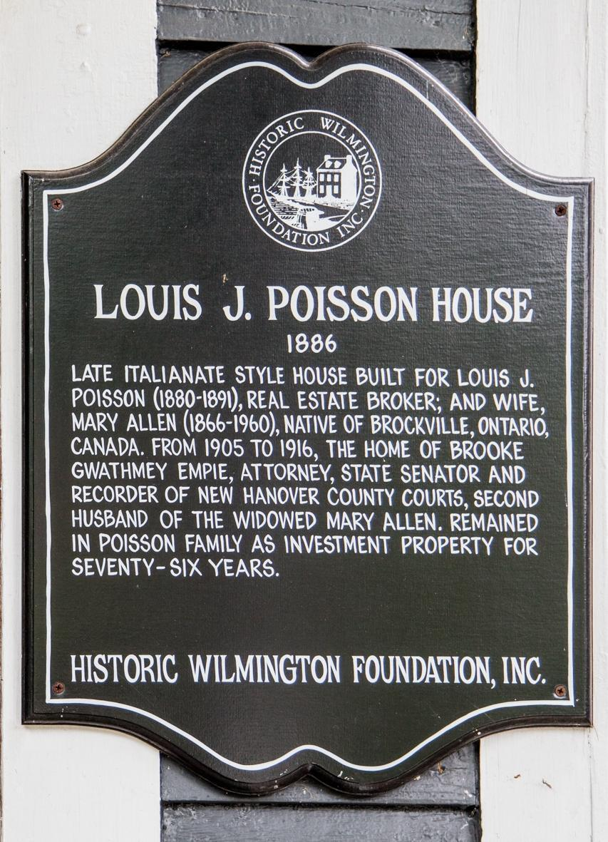
- Builder
- Architect
- Year built
- Original owners
  - year of birth and death
  - place of birth
  - occupation
- Owners with possession of house for 40% of life of the house at time of application
- Other significant owners
- Any major architectural changes to
the structure

You will use your research to prove the information required for your plaque application and the plaque text.

WHERE TO GET ALL THE INFO YOU NEED

Directories

You are looking for the name of the person(s) living in the home and their occupation, if available.

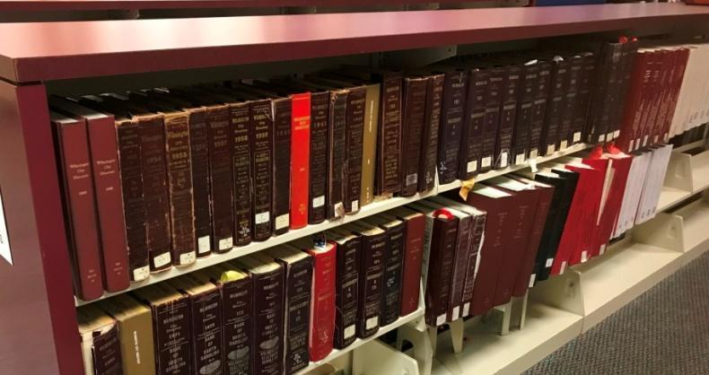
Not all directories are available online.
For listings from today back to 1963, you will have to go to the North Carolina Room at the downtown branch of the New Hanover County Library. You can take notes on paper or photograph the relevant pages (without flash). The individual pages do not include the year of publication, so be sure to note the year by changing the name of your photos.

You can search all available directories manually while at the library, but you may also use the following website to search directories from 1860-61 to 1963: http://www.digitalnc.org/collections/city-directories/

This site includes digital/searchable copies of city directories from 1860-61 to 1963. It does not present the directories in numerical order, but it is the easiest database to search. You can save the images to your computer.

Examples:

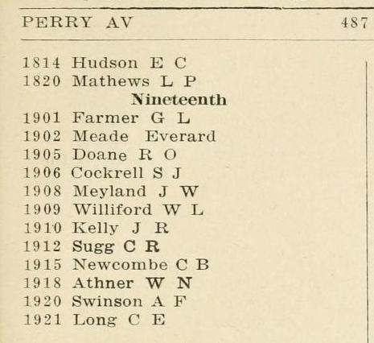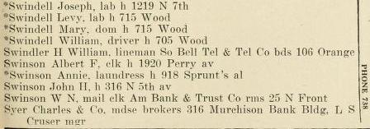
Index Listing

Bill Reaves Collections
These two collections (not available online) are available for view in the North Carolina Room. Bill Reaves collected newspaper articles and other documents that have been printed and bound in one collection, sorted by street, block, and address. The other collection is sorted by family name.
Block books Family names
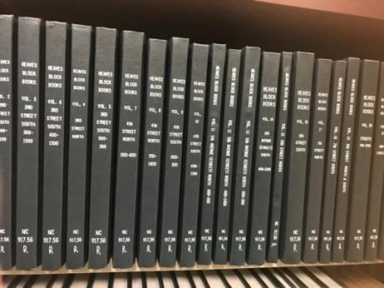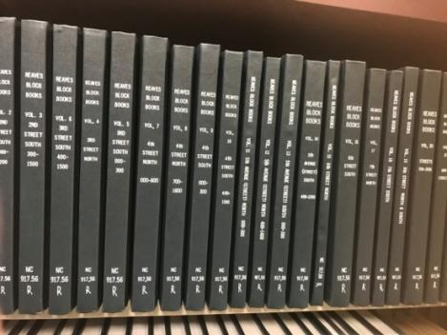

Example page:
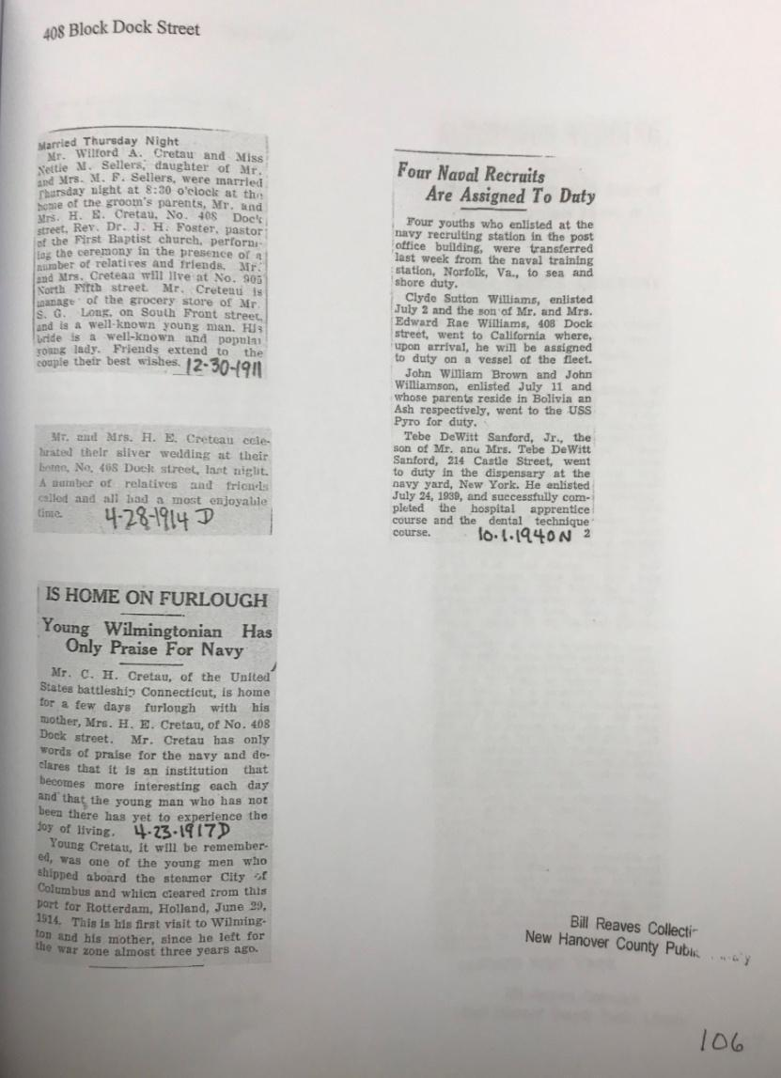

North Carolina Sanborn Insurance Maps
- Visit https://web.lib.unc.edu/nc-maps/sanborn.php.
- Go to “Browse Maps by City” on the right side of the page, and select “Wilmington.”
- Start by choosing the most current map “1915” at the bottom of the page.
- On the right side of the page, select the “Key Map” icon.
- On the key map, find the location of your house and note the page number. Then search for that page icon on the right side of the page and select.
It is best at this point to download the map page to your computer. Select “download” in the upper right of the page and choose the last option on the drop-down menu, “large.” Open the image and save it. Once the image is saved, you will be able to more easily magnify and crop images for your personal use.
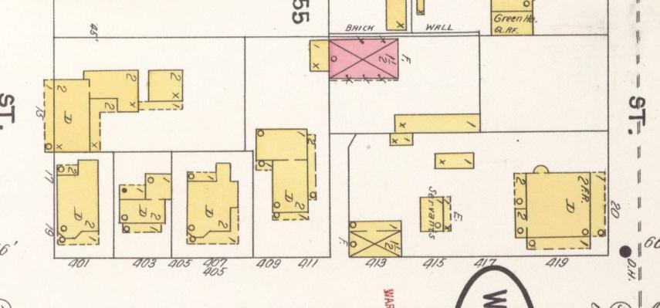
Continue the process for each year of the Sanborn Map publications until your particular lot is no longer included. Save even if the lot is present but the house is not. This will help prove the age of your home. Supplements that cover 1921, 1928, 1948, and 1955 are available for view in the North Carolina Room. Examples:
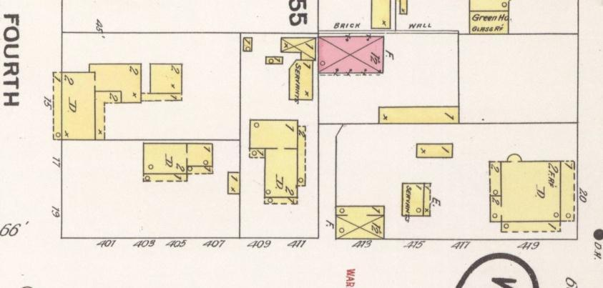
1898 1904
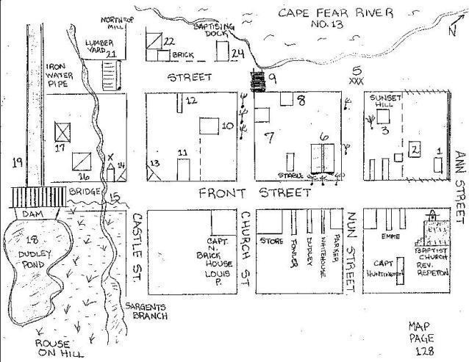
Nicholas W. Schenck Diary
Most useful if your home was built before 1900 in the downtown area, this diary by Nicholas Schenck contains recollections of pre-Civil War Wilmington—and includes diagrams and notations! Even better: the map is interactive. If your home is located somewhere in the image, click and it will go to the descriptions and sketches.

https://library.uncw.edu/web/collections/schenck/schenck-full.html

National Register of Historic Places

These documents are applications. Each includes listings of addresses that include an estimated date of construction, description of the house, and sometimes information related to the resident.
There are eight for Wilmington, but for a list of ALL National Register Historic Districts in NC:
https://www.ncdcr.gov/about/history/division-historical-resources/nc-state-historic-preservation-office/architectural-surveys-and-national-register-historic-places/north-carolina-national-register-historic-places/nc-listings-national-register-historic-places

Brookwood Historic District
Roughly bounded by Market St., Keaton Ave., Burnt Mill Creek, and Wallace Park.
https://files.nc.gov/ncdcr/nr/NH3472.pdf
Carolina Heights District ref # 99000317
Roughly bounded by Market St., 13th St., Rankin St. and 19th St.
https://files.nc.gov/ncdcr/nr/NH1482.pdf
Carolina Place District ref # 92001086
Bounded by Market St., Wallace Park, Gibson Ave., Wrightsville Ave., and S. 18th St.
https://www.ncdcr.gov/media/1510/download
Market Street Mansion District ref # 75001284
1704, 1705, 1710, 1713 Market St.
https://files.nc.gov/ncdcr/nr/NH0526.pdf
Masonboro Sound Historic District ref #92001334
East side Magnolia Dr. and 7301--7601, 7424 and 7506 Masonboro Sound Rd.
https://www.ncdcr.gov/media/1560/download
Sunset Park Historic District ref # 03001265
Roughly bounded by Carolina Beach Rd., Southern Blvd., Burnett Blvd., and Sunset Ave.
https://files.nc.gov/ncdcr/nr/NH2674.pdf
Westbrook Ardmore Historic District ref # 08001414
Bounded by Dock St., Wrightsville Ave., Queen and Lingo Sts., and by S. 14th St.
https://files.nc.gov/ncdcr/nr/NH2528.pdf
Wilmington Historic & Archaeological District ref # 74001364
Roughly bounded by Wright, S. 7th, and Harnett Sts., and N/S line 100 yds. W of Northeast Cape Fear River.
https://files.nc.gov/ncdcr/nr/NH0003.pdf

Example:
“Frank T. Abbott House; frame Craftsman bungalow with hip-roofed, double-pile
main block; gabled front wing; three-bay facade; entrance bay and recessed right (west) bay sheltered by porch with square-section posts and balusters: crossette-pattern sidelights; interior chimney; asbestos shingle siding; Frank T. Abbott, president of Clarks Lumber Co. and Millet Lumber Co., was an early and long-time owner and occupant.”

New Hanover Tax Records

https://etax.nhcgov.com/pt/Search/Disclaimer.aspx?FromUrl=../search/commonsearch.aspx?mode=owner

Every time you go to this site, you will have to accept the “Disclaimer” by clicking “Agree.”

On the next page, you can choose to search by Name or Address by using the “Property Records” tab on the top left. Using the address is best.

Click on the correct listing for your house. (Note: Sometimes there will be more than one.)
The profile page appears first and gives general information, including the current owner and block and lot numbers.

Click the “Sales” tab on the left side. Here is an example of what will appear:

Sale Date | Sale Price | Grantee | Grantor | Book | Page | Sale Key
18-NOV-16 | $215,000 | MAY DEAN F KRISTIN M | CHAMBERLIN SETON D | 6018 | 2311 | 544110
19-AUG-13 |  | CHAMBERLIN SETON D | CHAMBERLIN THOMAS V | 9908 | 1213 | 489835
30-JAN-03 | $175,000 | CHAMBERLIN SETON D | HARRIS LYNN S DONALD E | 3624 | 0787 | 151289
24-NOV-92 | $0 | STANLEY LYNN S | LAYTON ALONZO M | 1632 | 0847 | 151288
12-NOV-92 | $0 | STANLEY LYNN S | LAYTON ALONZO M | 1630 | 0453 | 151287
01-JAN-86 | $38,500 | LAYTON ALONZO M ETAL | NICHOLS JOYCE CISSEL | 1315 | 0383 | 151286
01-NOV-80 | $21,000 | NICHOLS JOYCE CISSEL | HUDSON TERESA | 1177 | 1514 | 151285
01-DEC-76 | $12,000 | HUDSON TERESA | * NOT IN SYSTEM * | 1082 | 0937 | 151284

Either jot down or copy and paste the “Sales” information including sale date, sale price, Grantee, Grantor, book, and page. You will use this information to obtain copies of those deeds.

Other helpful information on this page includes the “Sketch” and “Parcel Map.” These provide the exact dimension and location of the current home and can be used to compare with old maps to identify any major changes over time. You can copy and paste to a separate document or print directly from the page. Examples:

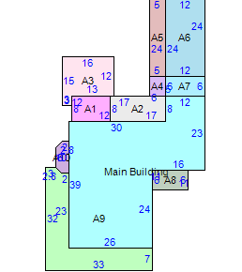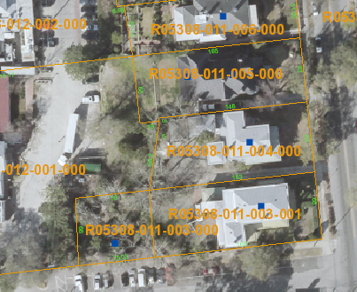
Sketch Parcel Map

IMPORTANT NOTE: Ignore any reference to the age of the home. It is incorrect more often than not.
New Hanover County Register of Deeds
Applications must include a one copy of every deed for your property from the time your home was built. You will also have to provide an abstract of the information for the committee to review. LINK: https://registerofdeeds.nhcgov.com/services/records-search/
Every time you go to this site you will have to click the “I have read and understood the information above…” tab at the bottom of the page. On the next page you can use the information from the Tax Records to search for original Deeds.
In the lower left side of the page. Use the “Book-Page (or) File # Search.” The “Book Type” is already set to “Official Public Records.” Insert the “Book” and “Page” numbers, then click “Search.”
On the new page, you can view the original document by choosing “TIFF” or “PDF” in the far right top corner. When viewing the document, you can choose to print, save, or both. This type of search only covers 1954 to present. To search older deeds, you will have to use a different type of search.
For older deeds, look to the lower left corner and click “Old Index Books.” Here you will find a choice of “1954-1977,” “1926-1953,” and “1728-1925”. (Note that there is an overlap for 1954-1977.)
Use the name of the “Grantor” on the newest deed from your search to find the “Grantee” in the old index books. Make note of the description of the lot size and placement within the block, block number, and lot number.
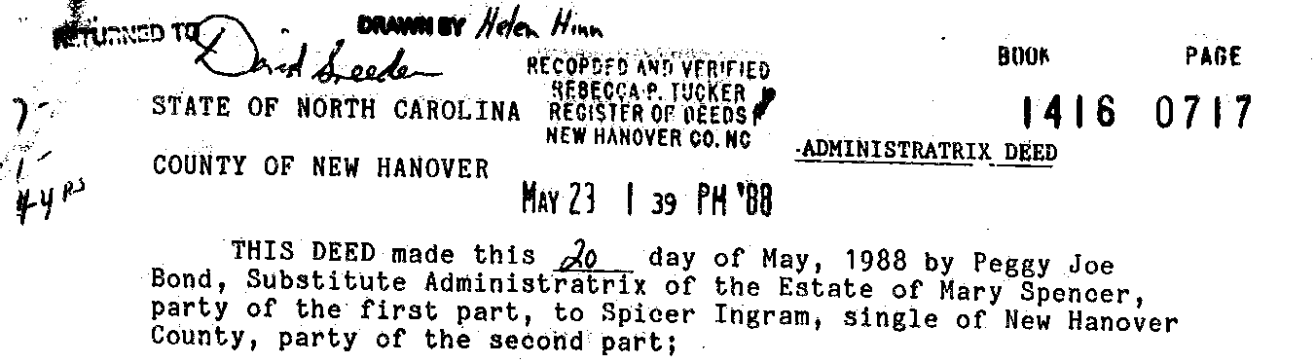

You are looking for the date, type of deed, grantor, grantee book number and page number.
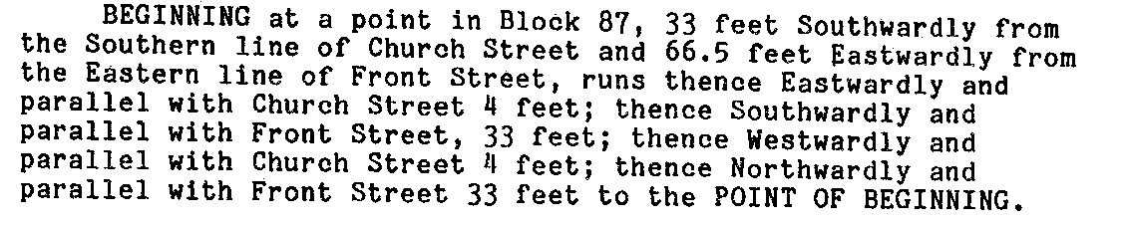
You are also looking for the description of the lot in order to compare it to newer and older deeds.
Vital Statistics from Ancestry.com
A library addition of ancestry.com can be accessed at the library. You cannot access this site remotely with your library card. This edition is limited in that you cannot build a family tree or save to the site. But, you will be able to access records, print and/or save to a flash drive.
Some documents you will find:
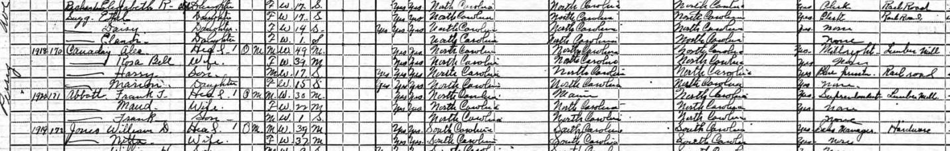
Federal Census provides residence, birth year, birth place and occupation:
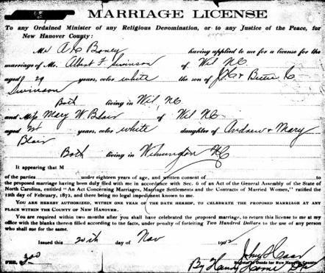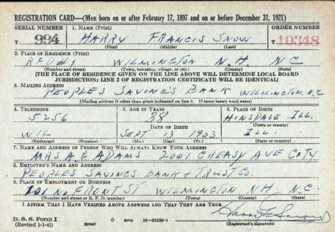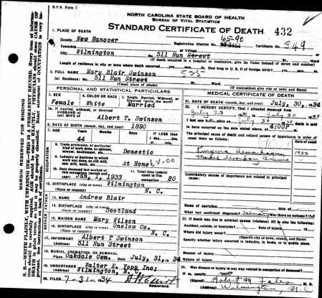
Marriage licenses, death certificates, and military records are also available.
There are many other items you can find that aren’t necessary for the application, but are fun and informative (e.g., photos, family bible inscriptions, stories, high school yearbooks, letters, etc).

Newspapers
Newspapers can provide information about house sales, marriages, births, deaths, and occupation. They will also fill out the stories of the people that lived in your home. If you have a library card, you can access this database from home.

https://login.proxy128.nclive.org/login?url=https://www.nclive.org/cgi-bin/nclsm?rsrc=411

Log in your library card number. This will take you to newpapers.com
NC edition.

Change the parameters. For example, if you know that “John Smith” lived at “310 Bladen,” put “John Smith” in the search bar. If John Smith lived at 310 Bladen from 1910 to 1915, change the timeline to 1909 to 1916. Then select only Wilmington newspapers.
Another option is to search by address. Unfortunately, buildings were often described in the papers by proximity, not by address. So, this is a bit trickier.

Examples:

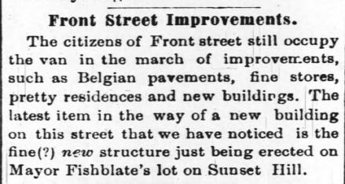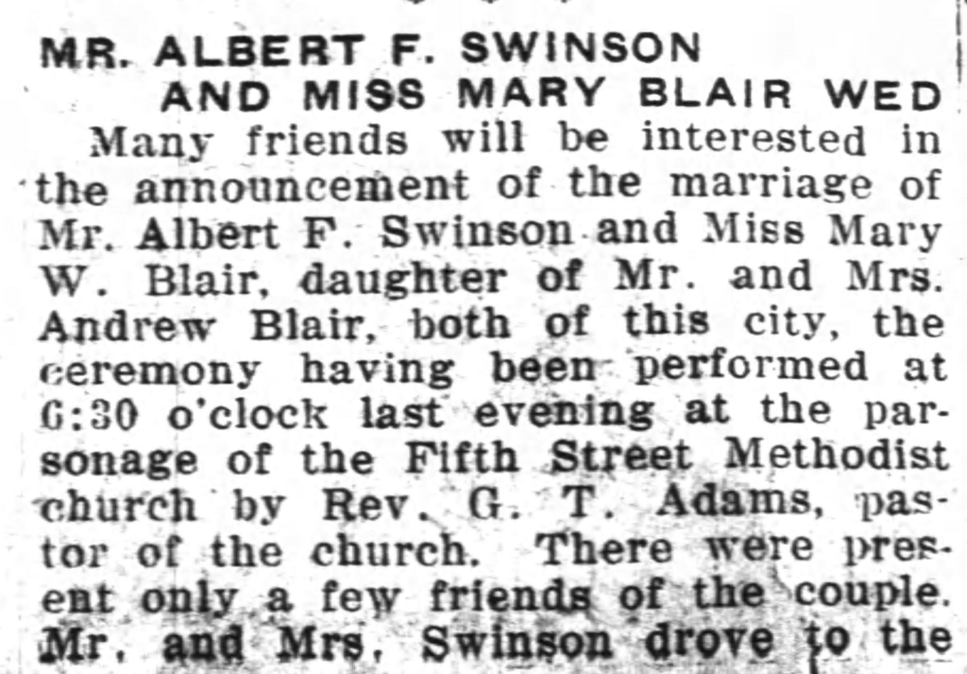

PUTTING IT ALL TOGETHER

You can follow the instructions on the application form, or simply use the example application on the following pages for your model. Be sure to list on the summary worksheet a source for every piece of information, and then to have a copy of that source material later in the application. Even if it seems obvious how/where you got the information, you must list the source!

Please note that for every copy of source material the relevant portions should be highlighted and/or otherwise typed out to ensure legibility. (The“Snip & Sketch” function on a PC, or the “screen capture” function on a Mac–by using Command + Shift + 4–can be very helpful for copying portions of images on your screen.)

Include every section that is in this example application: Summary Worksheet, Narrative Summary, Chronology, Deeds, Directories, Federal Census, Vital Statistics, Maps, Newspapers.

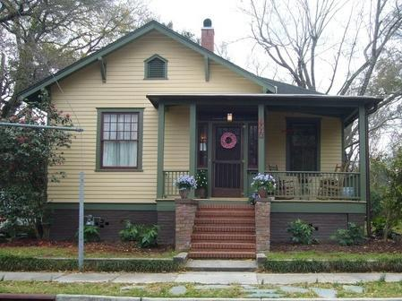

1920 Perry Avenue
Wilmington, NC 28403

Name(s) of Homeowner(s):
Phone:
Email:
Mailing Address:

Summary Worksheet

Applicant’s Name:
Phone:
Email:
Address of Property: 1920 Perry Avenue, Wilmington, NC 28403
Block & Lot(s): Block 26, Lot 13 and part of Lot 14

Research Information

Original Owner Source of Information

Full name: Albert Franklin Swinson Deeds, Death Cert.
Birth date: 12 Mar 1883 Death Cert., WWI Reg.
Place of birth: Sampson Co, NC Death Certificate
Death date: 4 Apr 1954 Death Certificate, Oakdale
Place of death: Fayetteville, NC Death Certificate
Occupation: clerk ACLRR Directories, WWI Reg.
Other Person on Deed: Mary W Blair Deeds, Death Cert., Marriage
Relationship (husband, sister, parter, etc.): wife Deeds, Death Cert., Marriage
Birth date: 9 Sep 1888 Death Certificate
Place of birth: Wilmington, NC Death Certificate
Death date: 30 Jul 1934 Death Cert., Oakdale
Place of death: Wilmington, NC Death Certificate

Date of construction: 1917 Deeds, Directories
Dates of ownership: 1916-1918 Deeds, Directories
Other Important Owners Source of Information

Full name: Harry Francis Snow Deeds, Directories
Birth date: 13 Sep 1903 WWII registration, Oakdale
Place of birth: Hinsdale, DuPage Co IL WWII registration
Death date: 18 Mar 1980 Obituary, Oakdale
Place of death: Wilmington, NC Oakdale, Death index
Occupation: bank teller at Peoples Savings Bank and Trust
and Wachovia Bank Directories, WWII Reg.
Other Person on Deed: Christine Hope Walker Deeds, Obituary
Relationship (husband, sister, parter, etc.): wife Deeds, Obituary
Birth date: 17 Apr 1911 Obituary
Place of birth: Burgaw, NC Obituary
Death date: 10 Apr 1983 Obituary, Oakdale
Place of death: Wilmington, NC Obituary, Oakdale
Occupation: saleswoman at Younger Set and Belk-Berry Directories, Obituary

Dates of ownership: 1945-1993 Deeds, Directories
Narrative Summary

1992 National Register of Historic Places Registration Form for the Carolina Place Historic District, Section 7 Page 27 describes 1920 Perry Ave as;

“Frank T. Abbott House; frame Craftsman bungalow with hip-roofed, double-pile
main block; gabled f r o n t wing; three-bay facade; entrance bay and recessed right (west) bay sheltered by porch with square-section posts and balusters: crossette-pattern sidelights; interior chimney; asbestos shingle siding; Frank T. Abbott, president of Clarks Lumber Co. and Millet Lumber Co., was an early and long-time owner and occupant.”

Although 1920 Perry is described as the Frank T. Abbott House, it was built in 1917 by Albert Franklin Swinson (1883-1954) railroad clerk and his wife Mary W. Blair (1888-1934).
The house is described as lot 13 and part of lot 14 in block 26. In 1916, A F and Mary Swinson purchased lot 13 and 14. At the time, Oscar and Lena Athner owned lot 15 and the Athner home was present in 1915. In 1916, A F and Mary Swinson sold part of lot 14 to Oscar and Lena Athner. Lot 14 was split to create 2 larger lots for the Swinsons and Athners.
In 1917, Swinson was living at 1922 Perry and Athner was living at 1918 Perry. By 1918, Swinson was at 1920 and Athner was at 1918. There is no listing for either 1920 or 1922 previous to 1917. The Swinsons lived in the home for two years.
From 1945 to 1993, the Snow family owned 1920 Perry. Harry Francis Snow (1903-1980) bank teller and wife Christine Hope Walker (1911-1983) retail salesperson purchased the home in 1945. Harry lived in the home until his death in 1980 and his wife Christine until her death in 1983. The house was vacant from 1984 until 1994. Their son, George Clifford Snow sold the house to Robert Marsh in 1993. The Snow family owned the house for 48 years.

Chronology

1883
Death Certificate-Albert Franklin Swinson, Born 12 Mar 1883 Sampson Co. NC

1890
Death Certificate- Mary Blair, Born 1890 Wilmington, NC

1903
WWII Registration-Harry Frances Snow-Born 13 Sep 1903 Hinsdale, IL

1911
Deed-American Suburban Corporation to Maggie H. Holland, lots 14 and 15, block 26
Deed-American Suburban Corporation to H. F. Wilder, lot 13, block 26
Deed-Maggie H. Holland and H. F. Wilder to W. M. and Susie Cumming, lots 13, 14 and 15, block 26
Obituary- Christine Hope Walker, Born 17 Apr 1911 Burgaw, NC

1912
Marriage Certificate- Albert F Swinson to Mary W Blair, 20 Nov 1912, Wilmington, NC

1914
Deed-W. M. and Susie Cumming to W. A. McGirt, lots 13 and 14, block 26

1915
Sanborn Map- 1920 Perry not present

1916
Deed-W. A. McGirt to A. F. and Mary Swinson, lots 13 and 14, block 26

1916
Deed-A. F. and Mary Swinson to Oscar and Lena Athner, part of lot 14, block 26

1917
Directory-A F Swinson (1922 Perry) clerk ACLRR

1918
Mortgage-A. F and Mary Swinson to William Struthers, Jr. and L. W. Moore, lots 13 and part of 14, block 26
Directory-A F Swinson elk
Mortgage-E. L. and Martha F. Shinn to William Struthers, Jr. and L. W. Moore, lot 13 and part of lot 14, Block 26
Mortgage-E. L. and Martha F. Shinn to William Struthers, Jr. and L. W. Moore, lot 13 and part of lot 14, Block 26

1919
Deed-E. L. and Martha F. Shinn to Frank T. and Maude M. Abbott, lot 13 and part of lot 14, block 26

1919-20
Directory-Ernest L Shinn agent Royal Mutual Life Insurance Co.

1920
Federal Census-Frank Abbott, head, 30 yrs old, born NC, superintendent lumber mill, Maud Abbott, wife, 22 yrs old, born NC, Frank Abbott, son, 1 yr old, born NC

1922
Directory-Frank T Abbott elk Hammer Lumber Co.

1923
Sanborn Map Supplemental-1920 Perry present

1924
Directory-Frank T Abbott president Clarks Lumber Co. & Millett Lumber Co.
1926
Directory-Frank T Abbott manager Coastal Lumber Co.

1928
Mortgage-Frank T. and Maude M. Abbott to William B. Campbell of Equitable Life Assurance lot 13 and part of lot 14, block 26
Directory- Frank T Abbott secretary treasurer Coastal Lumber Co.

1930
Federal Census-Frank T Abbott, head, 40 yrs old, born NC, proprietor wholesale lumber, Maude M Abbott, wife, 32 yrs old, born NC, Frank T Abbott Jr, son, 11 yrs old, born NC

1930-1934
Directory-Frank T and Maude M Abbott president treasurer Coastal Lumber Co.

1935
Deed-William B. Campbell to Equitable Life Assurance, lot 13 and part of lot 14, block 26

1936
Deed-Equitable Life assurance to James R. and Laura R Fisher, lot 13 and part of lot 14, block 26

1938-1943
Directory-James R and Laura P Fisher clerk ACCLRR Co.

1940
Federal Census-James R Fisher, head, 35 yrs old, born NC, auditing freight receipts steam railroad, Laura R Fisher, wife, 29 yrs old, born NC, Mary M Fisher, daughter, 7 yrs old, born NC
Bobby Jean, son, 5 yrs old, born NC

1945
Deed-James R. and Laura R. Fisher to Harry F. and Christine W. Snow, lot 13 and part of lot 14, block 26

1947-1952
Directory-Harry F and Christine S Snow teller Peoples Savings Bank and Trust Co.

1954
Death Certificate-Albert Franklin Swinson, Died 4 Apr 1954 Fayetteville, NC

1956
Directory-Harry F and Christine W Snow teller Wachovia Bank and Trust

1958
Directory-Harry F Snow teller Wachovia Bank and Trust, Mrs Christine W Snow saleswoman Younger Set, Charles E Snow stock clerk SBT&T, John D Snow USAF

1959-1960
Directory-Charles E Snow clerk SBT&T, Harry F and Christine W Snow teller Wachovia Bank and Trust, John D Snow USAF

1961
Directory-Harry F and Christine W Snow teller Wachovia Bank and Trust, John D Snow USAF, George C Snow student
1962
Directory-Harry F and Christine W Snow teller Wachovia Bank and Trust, John D Snow USAF

1963
Directory-Harry F and Christine W Snow teller Wachovia Bank and Trust, Clifford Snow engineer NECT-TV

1966-1978
Directory-Harry F Snow

1980
Obituary- Harry Francis Snow Sr, Died 18 Mar 1980
NC Department of Health. North Carolina Deaths, 1979-82- Harry Francis Snow Sr, death Mar 1980 New Hanover Co, NC

1980-1983
Directory-Christine Snow

1983
Obituary- Christine hope Walker Died 10 Apr 1983 Wilmington, NC

1984-1994
Directory-Vacant

1989
Deed-G. Clifford Snow to G. William Dobo and G. Clifford Snow lot 13 and part of lot 14, block 26

1992
Deed-G. Clifford Snow to G. William Dobo lot 13 and part of lot 14, block 26

1993
Warranty-G. William and Barbara Dobo to G. Clifford Snow, lot 13 and part of lot 14, block 26

1993
Warranty Deed-G. Clifford Snow to Robert C. March, Jr., 1920 Perry Ave.

1996
Directory-Robert March

1997
Deed-Robert C March, Jr. to Mark Allen Murphy and Pamela Pearl Tucker, lot 13 and part of lot 14, block 26

1998
Directory-Pamela Tucker

2000
Directory-Mark Murphy, Pamela Tucker

2001
Deed-Mark Allen Murphy and Pamela Pearl Tucker to William D. and Charlotte Emans Moore, lot 13 and part of lot 14, block 26

Deeds

1911
American Suburban Corporation to Maggie H. Holland, lots 14 and 15, block 26
Book 62 Page 639, Deed

1911
American Suburban Corporation to H. F. Wilder, lot 13, block 26
Book 66 Page 275, Deed

1911
Maggie H. Holland and H. F. Wilder to W. M. and Susie Cumming, lots 13, 14 and 15, block 26
Book 65 Page 425-6, Deed

1914
W. M. and Susie Cumming to W. A. McGirt, lots 13 and 14, block 26
Book 74 Pages 563-4, Deed

1916
W. A. McGirt to A. F. and Mary Swinson, lots 13 and 14, block 26
Book 87 Page 458, Deed

1916
A. F. and Mary Swinson to Oscar and Lena Athner, part of lot 14, block 26
Book 90 Pages 114-5, Deed

1918
A. F and Mary Swinson to William Struthers, Jr. and L. W. Moore, lots 13 and part of 14, block 26
Book 98 Pages 584-5, Mortgage

1918
E. L. and Martha F. Shinn to William Struthers, Jr. and L. W. Moore, lot 13 and part of lot 14, Block 26
Block 95 Pages 369-70, Mortgage

1918
E. L. and Martha F. Shinn to William Struthers, Jr. and L. W. Moore, lot 13 and part of lot 14, Block 26
Book 99 Page 19, Mortgage

1919
E. L. and Martha F. Shinn to Frank T. and Maude M. Abbott, lot 13 and part of lot 14, block 26
Book 110 Page 234, Deed

1928
Frank T. and Maude M. Abbott to William B. Campbell of Equitable Life Assurance lot 13 and part of lot 14, block 26
Book 183 Page 611& 612, Mortgage

1935
William B. Campbell to Equitable Life Assurance, lot 13 and part of lot 14, block 26
Book 243 Page 543, Deed

1936
Equitable Life assurance to James R. and Laura R Fisher, lot 13 and part of lot 14, block 26
Book 252 Page 447 & 448, Deed

1945
James R. and Laura R. Fisher to Harry F. and Christine W. Snow, lot 13 and part of lot 14, block 26
Book 381 Page 380, Deed

1989
G. Clifford Snow to G. William Dobo and G. Clifford Snow lot 13 and part of lot 14, block 26
Book 1444 Page 1449, Deed

1992
G. Clifford Snow to G. William Dobo lot 13 and part of lot 14, block 26
Book 1599 Page 1237, Warranty Deed

1993
G. William and Barbara Dobo to G. Clifford snow, lot 13 and part of lot 14, block 26
Book 1724 Page 758 Warranty Deed

1993
G. Clifford Snow to Robert C. March, Jr., 1920 Perry ave.
Book 1724 Page 761, Warranty Deed

1997
Robert C March, Jr. to Mark Allen Murphy and Pamela Pearl Tucker, lot 13 and part of lot 14, block 26
Book 2205 Page 400, Deed

2001
Mark Allen Murphy and Pamela Pearl Tucker to William D. and Charlotte Emans Moore, lot 13 and part of lot 14, block 26
Book 2973 Page 113, Deed

Directories

1917 A F Swinson (1922 Perry) clerk ACLRR
1918 A F Swinson elk
1919-20 Ernest L Shinn agent Royal Mutual Life Insurance Co.
1922 Frank T Abbott elk Hammer Lumber Co.
1924 Frank T Abbott president Clarks Lumber Co. & Millett Lumber Co.
1926 Frank T Abbott manager Coastal Lumber Co.
1928 Frank T Abbott secretary treasurer Coastal Lumber Co.
1930-1934 Frank T and Maude M Abbott president treasurer Coastal Lumber Co.
1938-1943 James R and Laura P Fisher clerk ACCLRR Co.
1947-1952 Harry F and Christine S Snow teller Peoples Savings Bank and Trust Co.
1956 Harry F and Christine W Snow teller Wachovia Bank and Trust
1958 Harry F Snow teller Wachovia Bank and Trust
Mrs Christine W Snow saleswoman Younger Set
Charles E Snow stock clerk SBT&T
John D Snow USAF
1959-1960 Charles E Snow clerk SBT&T
Harry F and Christine W Snow teller Wachovia Bank and Trust
John D Snow USAF
1961 Harry F and Christine W Snow teller Wachovia Bank and Trust
John D Snow USAF
George C Snow student
1962 Harry F and Christine W Snow teller Wachovia Bank and Trust
John D Snow USAF
1963 Harry F and Christine W Snow teller Wachovia Bank and Trust
Clifford Snow engineer NECT-TV
1966-1978 Harry F Snow
1980-1983 Christine Snow
1984-1994 Vacant
1996 Robert March
1998 Pamela Tucker
2000 Mark Murphy
Pamela Tucker

Federal Census

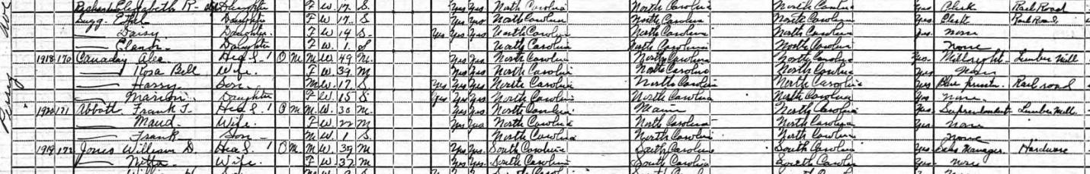
1920 Federal Census
Frank Abbott, head, 30 yrs old, born NC, superintendent lumber mill
Maud Abbott, wife, 22 yrs old, born NC
Frank Abbott, son, 1 yr old, born NC

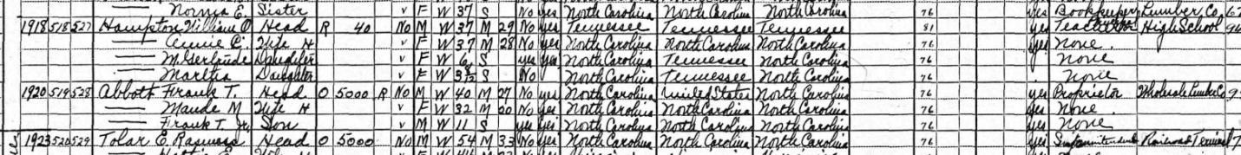

1930 Federal Census
Frank T Abbott, head, 40 yrs old, born NC, proprietor wholesale lumber
Maude M Abbott, wife, 32 yrs old, born NC
Frank T Abbott Jr, son, 11 yrs old, born NC

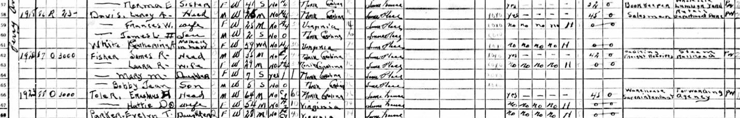

1940 Federal Census
James R Fisher, head, 35 yrs old, born NC, auditing freight receipts steam railroad
Laura R Fisher, wife, 29 yrs old, born NC
Mary M Fisher, daughter, 7 yrs old, born NC
Bobby Jean, son, 5 yrs old, born NC

Vital Statistics

North Carolina Death Certificate
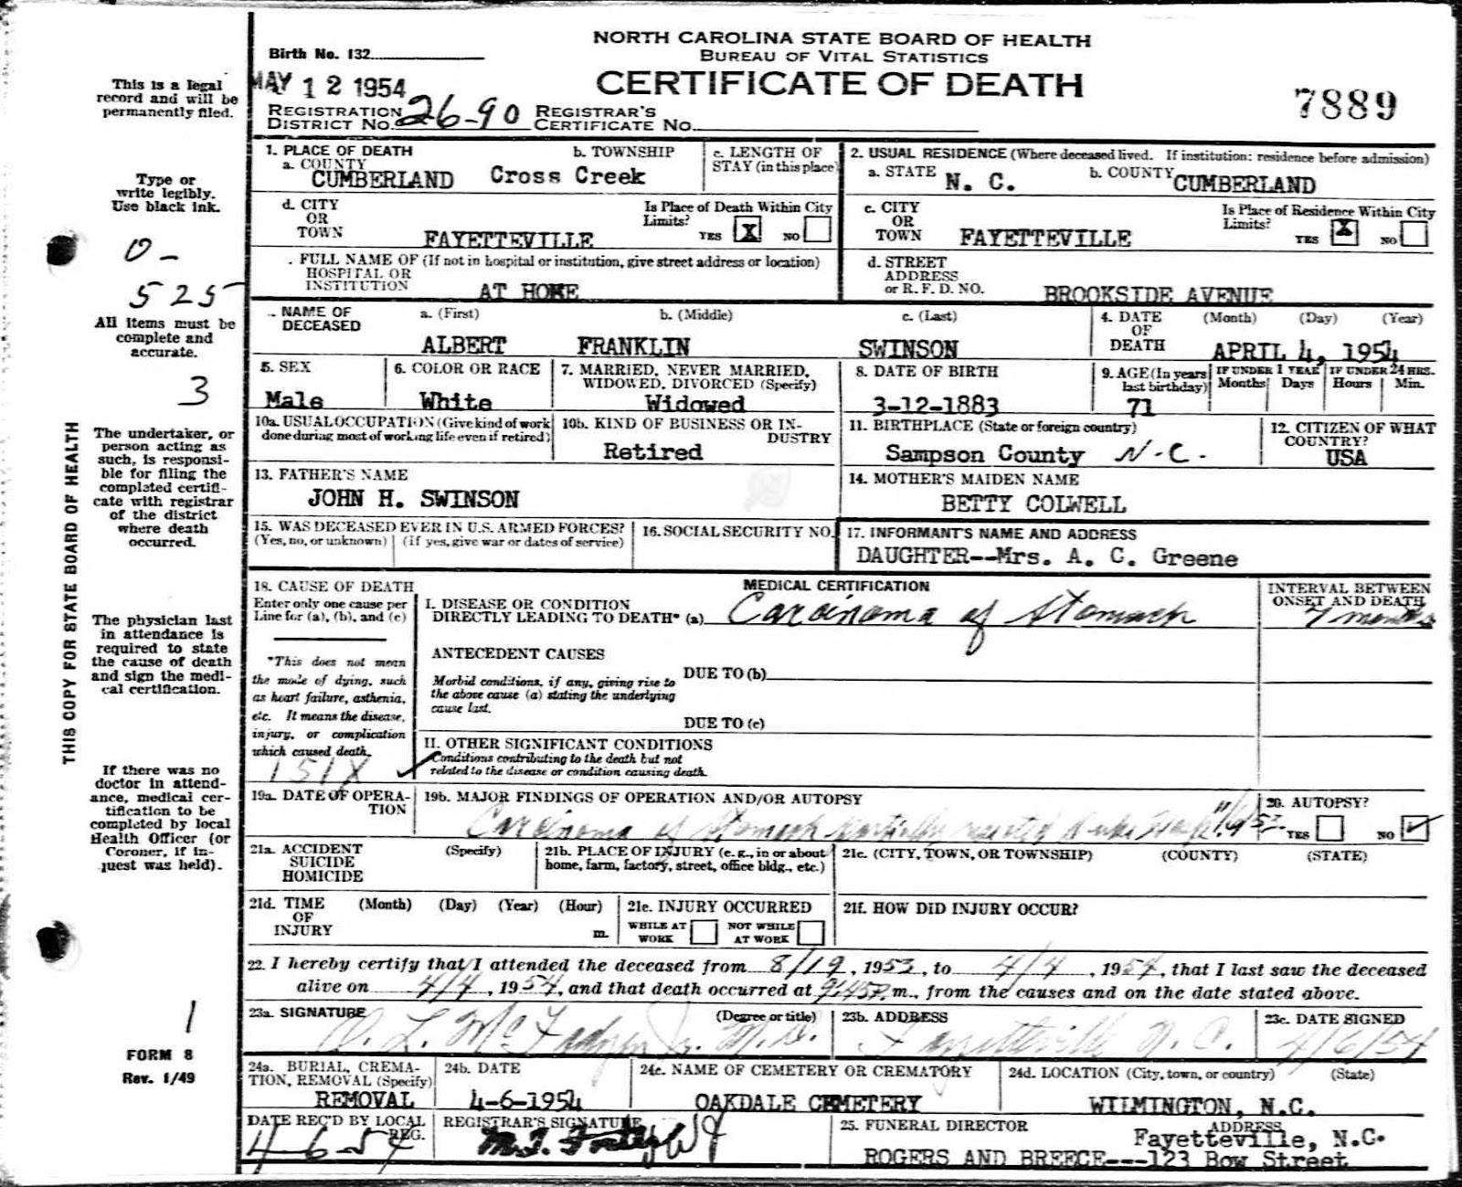
Albert Franklin Swinson
Born 12 Mar 1883 Sampson Co. NC
Died 4 Apr 1954 Fayetteville, NC
Buried Oakdale Cemetery

Oakdale Cemetery
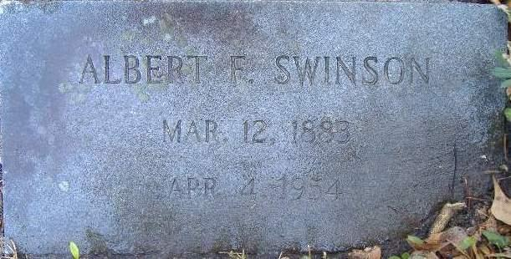
Abert F Swinson
12 Mar 1883-4 Apr 1954

North Carolina Death Certificate
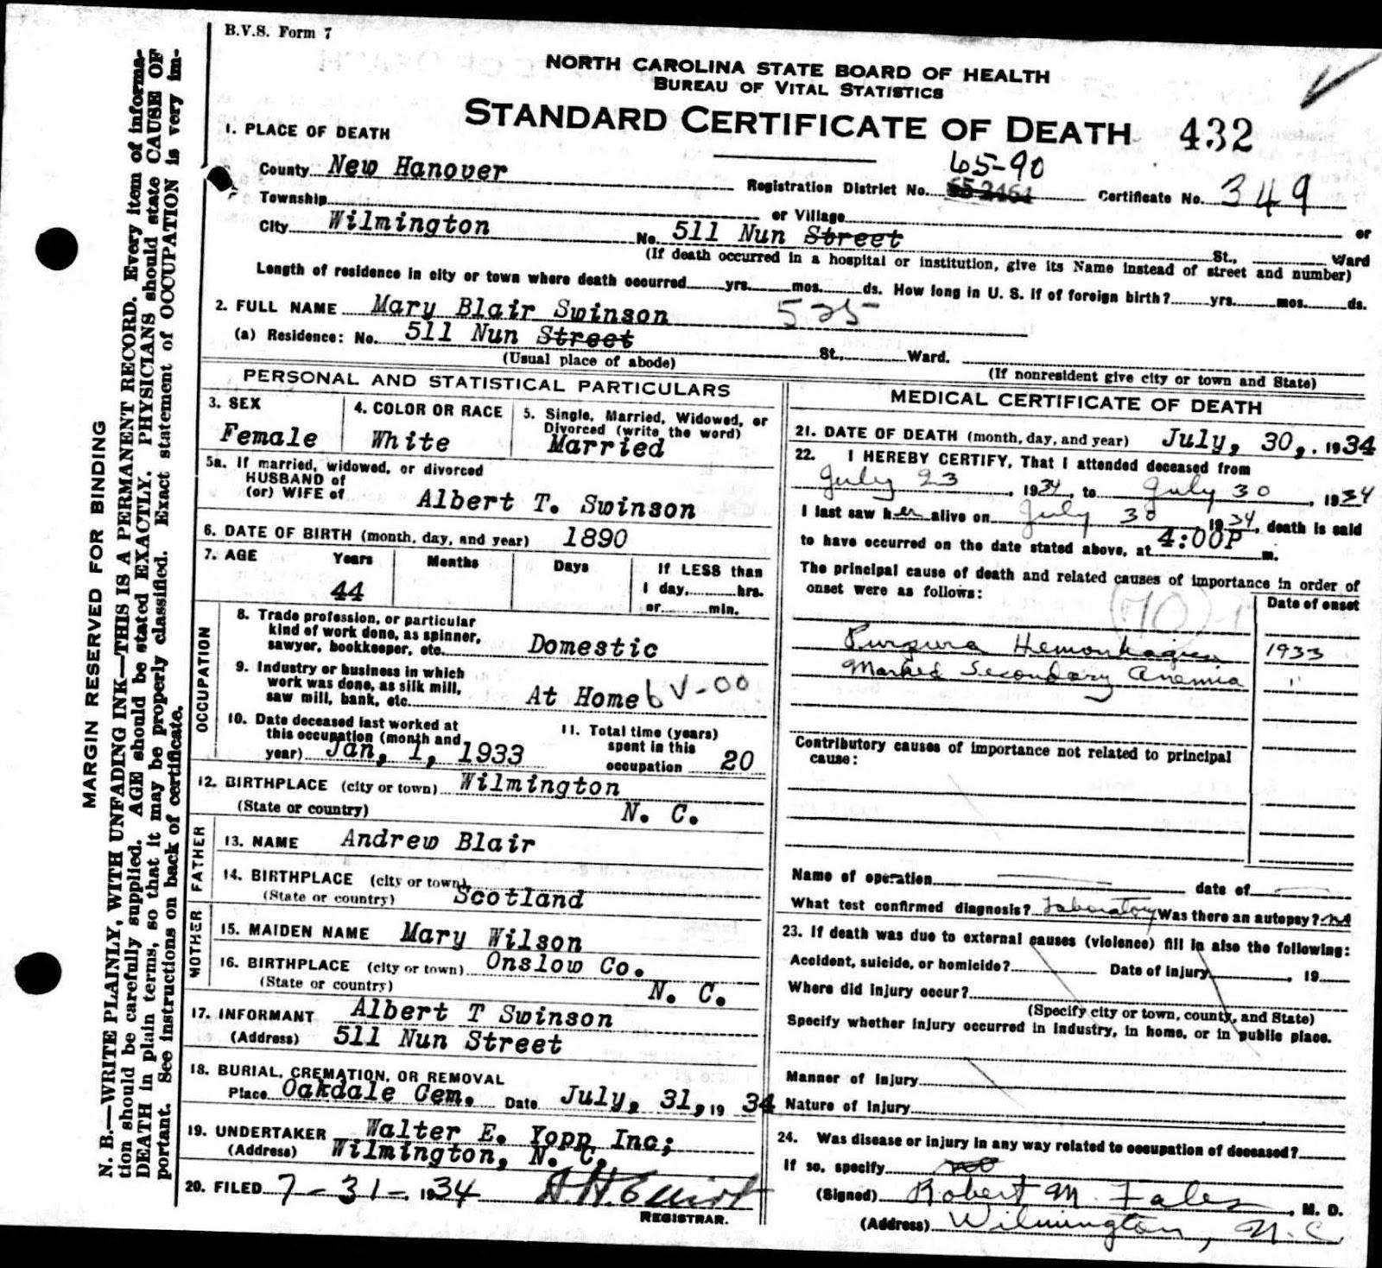
Mary Blair Swinson
Born 1890 Wilmington, NC
Death 30 Jul 1934 Wilmington, NC
Buried Oakdale Cemetery

Oakdale Cemetery
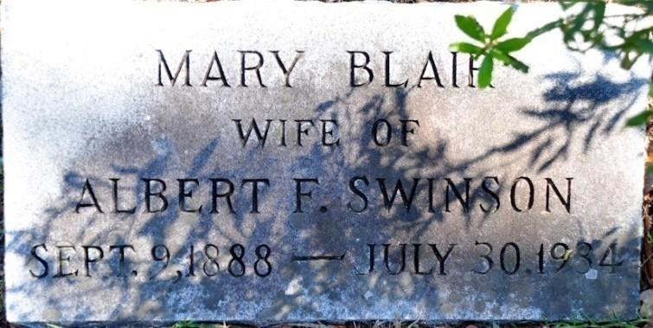
Mary Blair
9 Sep 1888-30 Jul 1934

Marriage License
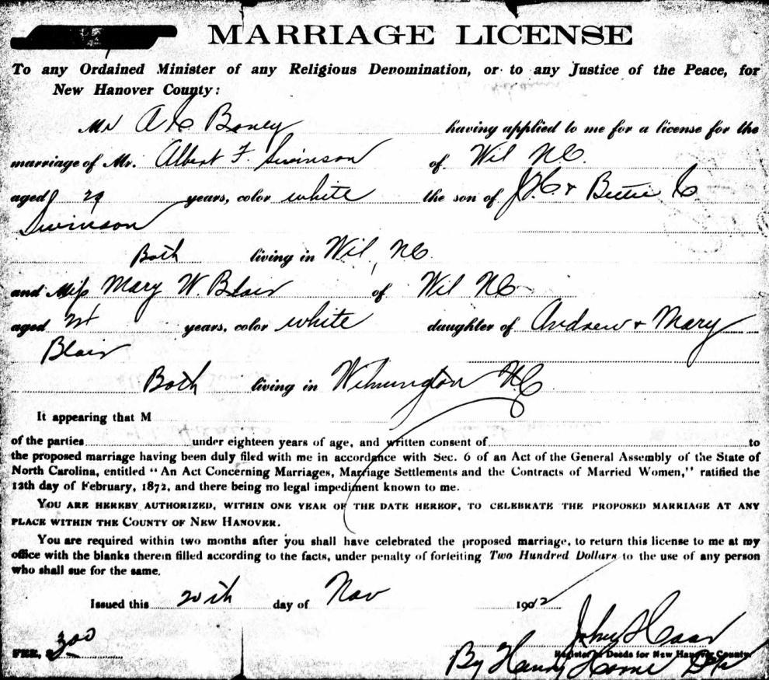
Albert F Swinson to Mary W Blair
20 Nov 1912
Wilmington, NC

Marriage Register New Hanover Co, NC 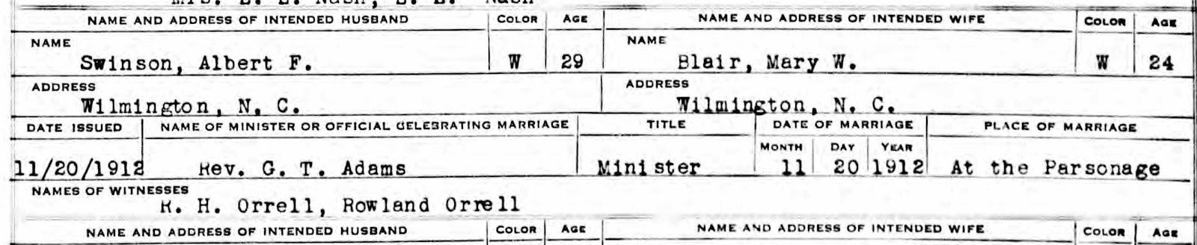
Albert F Swinson to Mary W Blair
20 Nov 1912
Wilmington, NC

WWI Registration
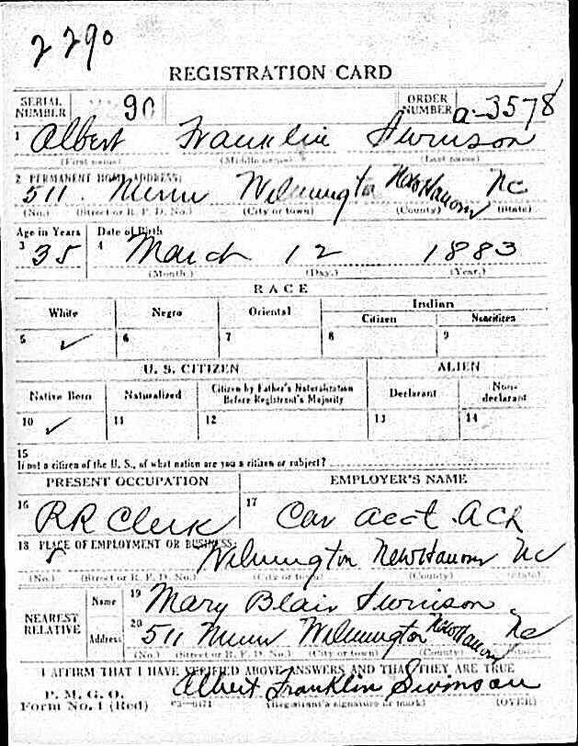
Albert Franklin Swinson
Birth 12 Mar 1883
Occupation Railroad Clerk
Wife Mary Blair Swinson

Star News Obituary 12 Apr 1983
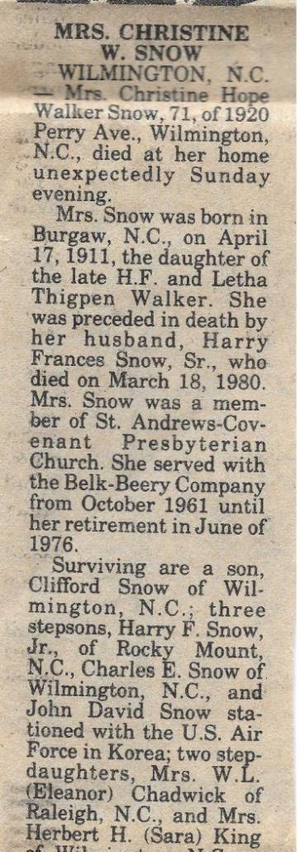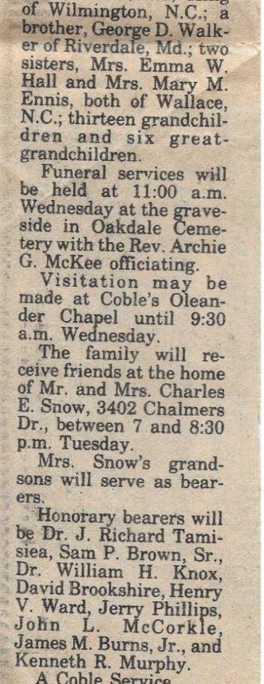
Christine Hope Walker Snow
Born 17 Apr 1911 Burgaw, NC
Died 10 Apr 1983 Wilmington, NC
Husband Harry Francis Snow Sr
Died 18 Mar 1980
Son Clifford Snow

Oakdale Cemetery
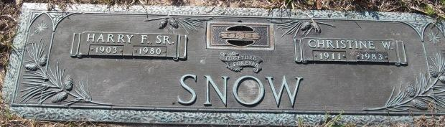
Harry F Snow Sr 1903-1980
Christine W Snow 1911-1983

WWII Registration
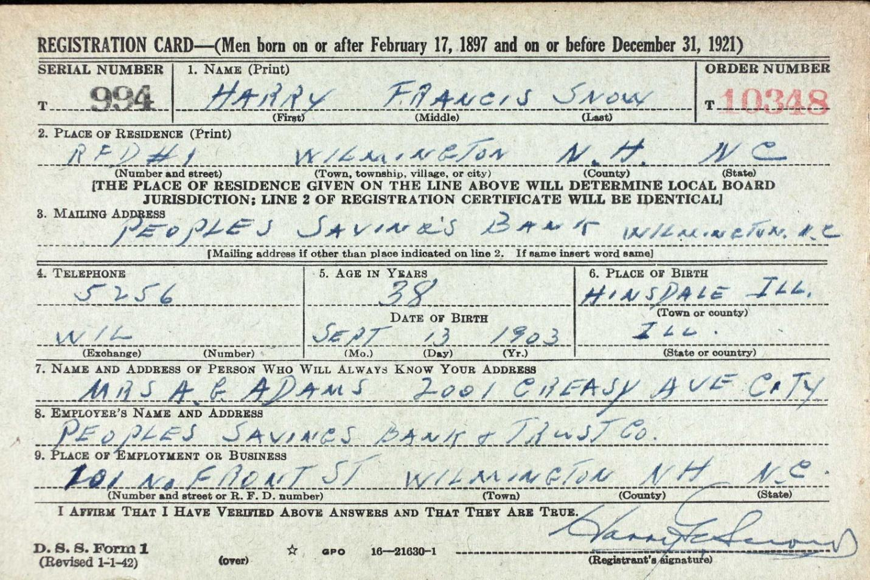
Harry Frances Snow
Born 13 Sep 1903 Hinsdale, IL
Employer Peoples Savings Bank

NC Department of Health. North Carolina Deaths, 1979-82
Harry Francis Snow Sr
Birth 13 Sep 1903
Death Mar 1980 New Hanover Co, NC

Maps
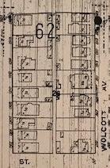
1915 Sanborn Map 1923 Sanborn Map Supplemental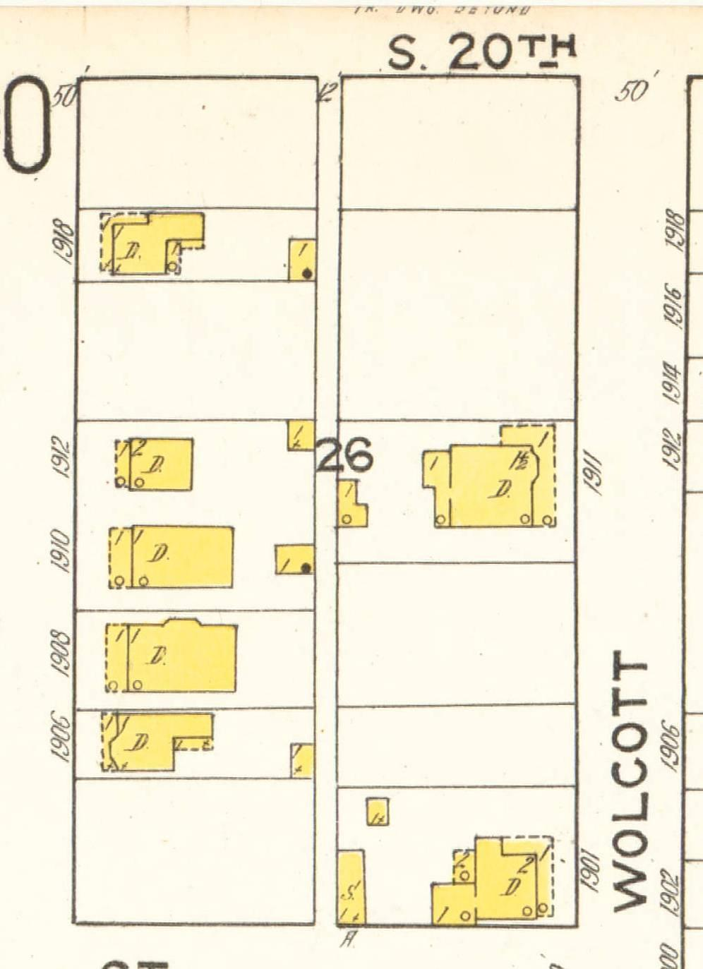

Newspapers

Wilmington Morning Star 21 Nov 1912

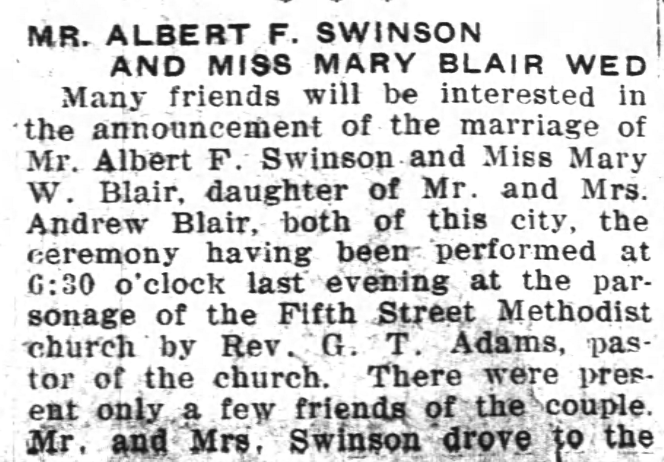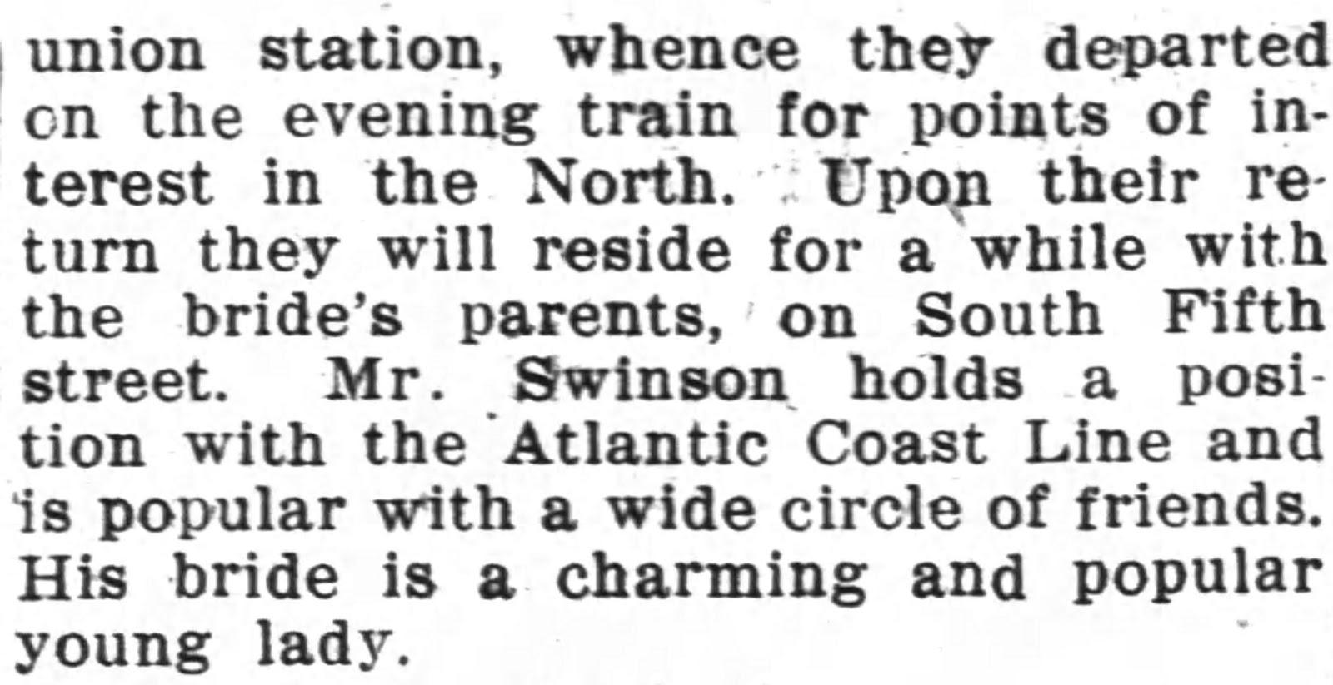

Wilmington Messenger 27 Nov 1907
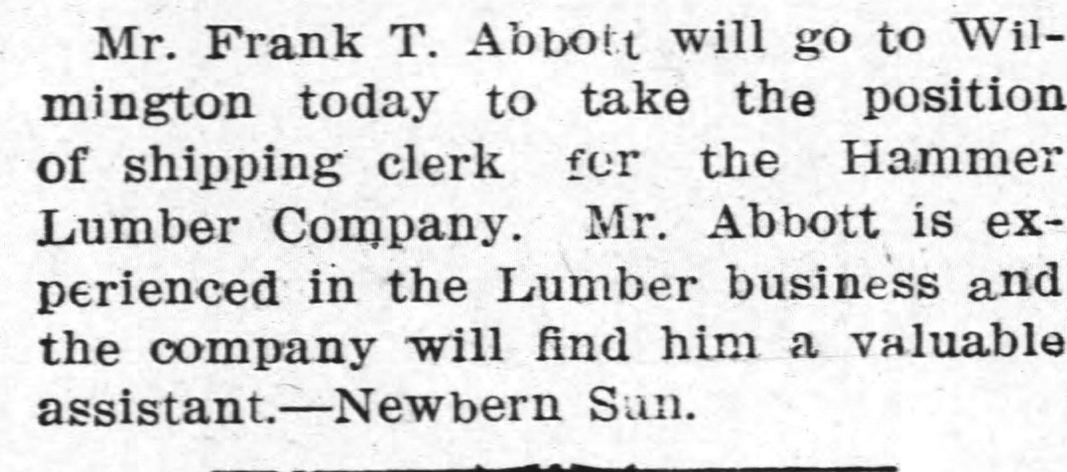

Wilmington Morning Star 11 Apr 1917
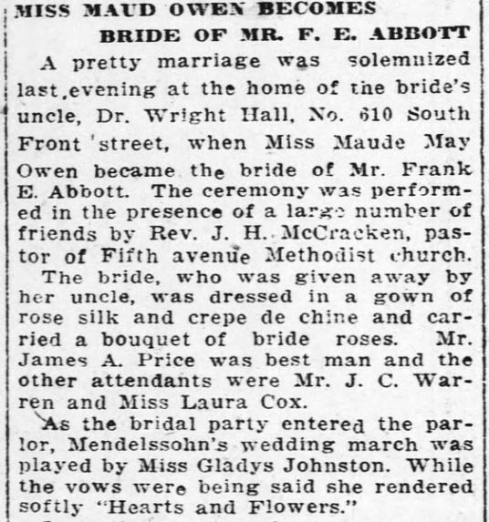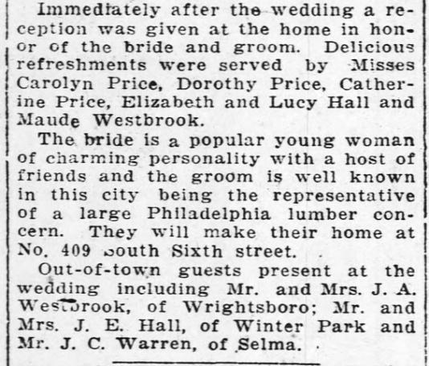

Wilmington Morning Star 24 Sep 1919
