Historic Wilmington Foundation
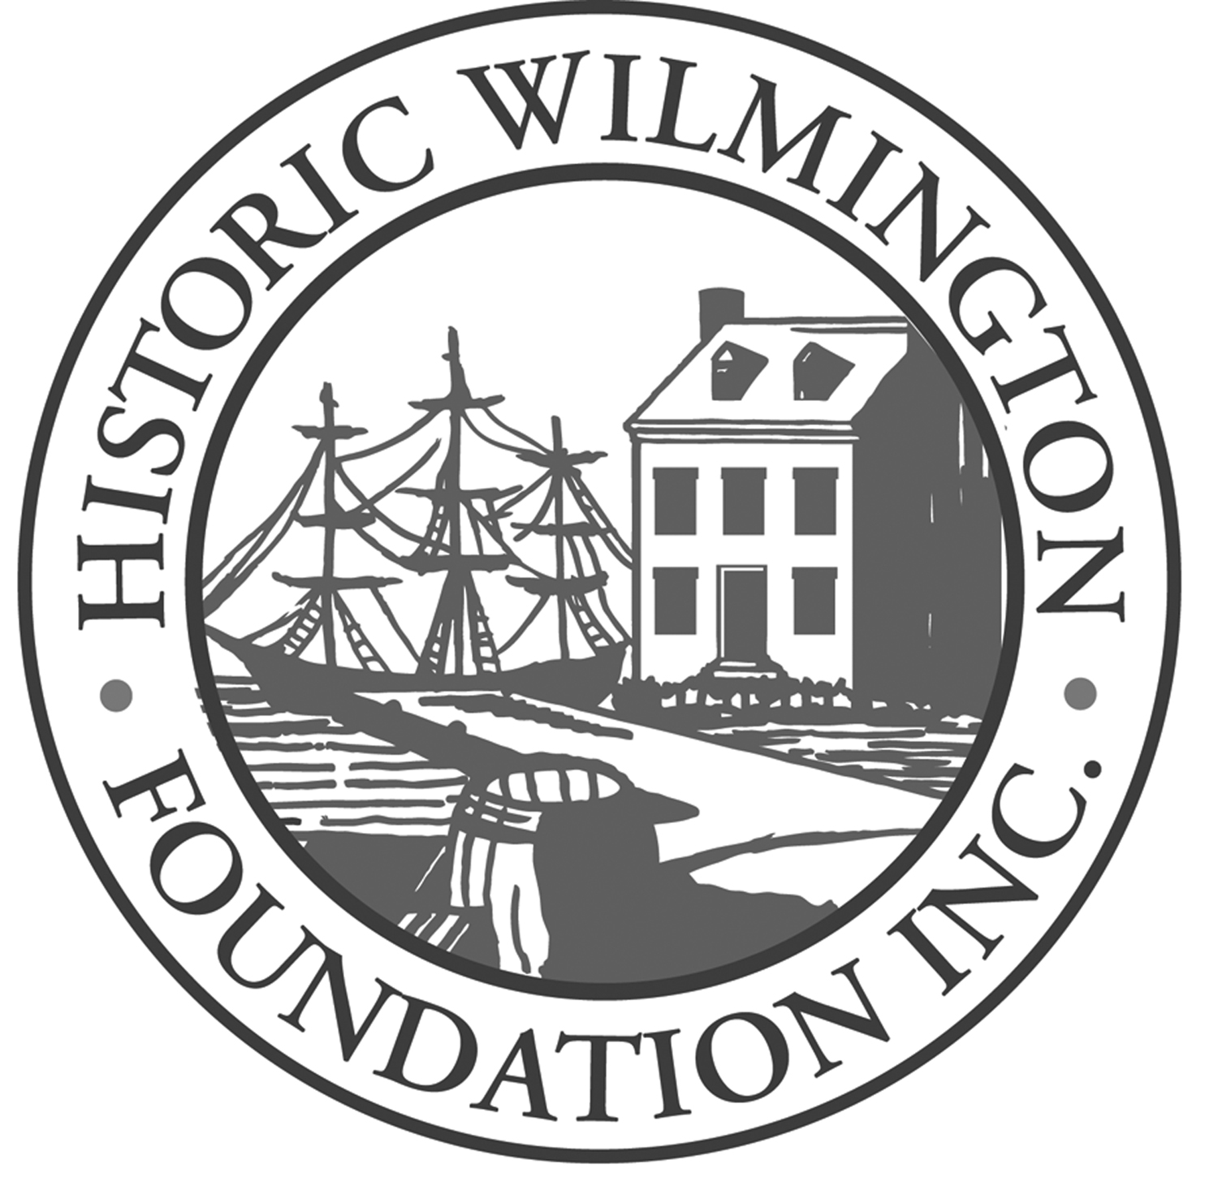

Plaque Application & Instructions
Updated April 2022

To apply for a plaque, complete the attached application in full. If certain facts are not available, give the reasons why. Please keep in mind that the information you gather is a permanent record of your building and will be available to historians and researchers for years to come.

Historic Wilmington Foundation’s plaque program is not connected with the City of Wilmington’s Design Review Process. For more information about that process, please contact the City of Wilmington’s Historic Preservation Planning Department.

When completed, submit two copies of the application and supporting documentation with at least two color photographs of your building to the Foundation office at 211 Orange Street. Please double-side the hard copy. The Foundation would also welcome receiving the entire application in an electronic form—in ONE pdf document please. You may submit a thumb drive, or email or Dropbox one large electronic file to plaques@historicwilmington.org. Any electronic version of your application will be in addition to the initial hard copy of the application.

Application Review Process
The Plaque Committee typically meets on the 2nd Wednesday of each month to review plaque applications. Applications must be submitted to the Foundation office at least one month prior to the meeting to ensure inclusion on the agenda. The Committee reviews applications in the order they are received, and once they are approved the signs are hand-painted by a local artist. Incomplete applications will not be reviewed by the committee; please ask HWF if you have questions during the process to ensure your application is complete. It is common for the process from application submission to final plaque creation to take up to four to six months.
We also offer a plaque presentation ceremony when the plaque is completed. Call HWF’s office for details.
Researching the history of your building is an exciting and rewarding learning experience, and the HWF plaque program provides a great way to document the history of your house. To help get you started, we’ve listed on the next page the answers to some of the most commonly asked questions about our plaque program.
FREQUENTLY ASKED QUESTIONS:

How do I know if a building is eligible for a Foundation plaque?
Buildings at least 75 years old that are located in New Hanover, Brunswick or Pender County are eligible for a HWF plaque. Historic alleys over 75 years old can be marked with a plaque. Properties over 50 years old in historic beach communities such as Wrightsville Beach, Carolina Beach and Kure Beach are also eligible for a plaque.

How is the color of the plaque determined?
As of November 2019, HWF plaques come in six different colors: sapphire, goldenrod, black, russet, sea oats, and green. See HWF’s website for photos of the various plaque colors.
- Buildings 200-years-old or older receive a sapphire plaque with white lettering.
- Buildings 150- to 199-years-old receive a goldenrod plaque with black lettering.
- Buildings 100 to 149-years-old receive a black plaque with white lettering.
- Buildings 75- to 99-years-old receive a russet plaque with white lettering.
- Buildings 50 years or older at the beaches receive a sea oats plaque with black lettering.
- Historic alley plaques are green with white lettering.

Who does the research for the plaque text?
Research is typically completed by the owner and submitted to the HWF Plaque Committee for review in the form of the application. The application is designed to lead you step-by-step in your research. If the Committee needs more information, a member will contact you and explain what information you need to provide before the next meeting. If you choose, you may hire someone to do the research for you. Call 910.762.2511 for a list of researchers, or go to HWF’s website and review the list: historicwilmington.org/plaques.

Who decides on the wording of the plaque?
After the Committee approves the research, they compose a plaque text for the building. HWF staff will send you a copy of the approved text to review. If you have any questions or suggestions concerning the plaque text, the committee will work with you, within the current standards set for HWF plaques. (For buildings, this generally means details on the plaque will only refer to the exterior architecture of the building—not interior—and will include names and details of owners/occupants who were in the building for at least 40% of the life of the building.) When pleased with the final product, the applicant submits payment to HWF, and we proceed with ordering the hand-painted plaque.

How much does a plaque cost?
Effective October 1, 2020, the price of a new plaque is $345 for members of the Foundation and $395 for non-members (fee includes a “Family/Household” level membership to the HWF). This is the cost of the hand-painted plaque plus staff time. (There is a $50 discount for multiple or replacement plaques—see page 3.)

How long does the process take?
The Plaque Committee typically meets on the 2nd Wednesday of each month to review applications. Applications must be submitted to HWF’s office at least two weeks prior to the meeting to ensure inclusion on the agenda. The Committee reviews applications in the order they are received, and it is common for review process to take several months. Then, once the plaque text is approved and HWF has received payment, the creation of the plaque by a local artist may take 12-16 weeks.

If my plaque is weathered and old, can I get a new one?
If your plaque has seen better days, you will need to order a new one through the same process as a new applicant. However, you have the advantage of reviewing the original application on file in the HWF office archives, so you may have to do very little additional research as you complete a new application. You also receive a discount: Effective October 1, 2020, a “repaint” is $295 for members and $345 for non-members, which will include a 1-year “Household/Family” level membership with HWF.

My house got older—how do I get a plaque in a different color?
Likewise, if your house has graduated from 99 years to 100 or from 149 to 150, you will need to order a new plaque through the same process as a new applicant. However, you have the advantage of reviewing the original application on file in the HWF office archives, so you may have to do very little additional research as you complete a new application. You also receive a discount: Effective October 1, 2020, a “repaint” is $295 for members and $345 for non-members, which will include a 1-year “Household/Family” level membership with HWF.

What happens to the researched information after my plaque is approved?
The information you gather in the application process is a permanent record of your building and will be available to historians and researchers for years to come. The plaque application worksheet and all additional information generated by your research will be filed permanently at Historic Wilmington Foundation headquarters. A copy is also kept in the Local History Room of the New Hanover County Library (call 910.798.6305 for hours of operation). Some plaque research is now being placed online at the Port City Architecture map maintained by the public library, and displayed on HWF’s website: historicwilmington.org/downtown-plaque-map.

What if I get stuck in the research process?
Don’t worry—we can help! Contact our staff liaison by calling 910.762.2511 or emailing plaques@historicwilmington.org to talk through your questions and difficulties. We also have many volunteers who are more than happy to assist, and staff can put you in touch with them by request.
Instructions for Completing the Plaque Application

Much of the information requested on the worksheet will appear on the plaque. It is important that dates and names are accurate. The source of all information must be recorded in the space provided on the worksheet and copies of the source material must be included.

- Address of house, block and lot numbers are stated after applicant’s name and address. If the house or building has been moved from another site, the former location should be noted as well.

- The building will be named when possible for the original owner or resident. Other owners or residents may be added if they occupied the building for 40% of its life, if they made significant architectural changes to the building, or if they are deemed to have been more important to the history of the city or county.

- The Plaque Committee assigns the name on the plaque based on the information presented. The name and the following information provide the house or building with personality and make for a meaningful plaque.

- Dates of ownership by the first and/or other significant owners are included on the plaque.

- Name of owner(s) and co-owner/spouse (if applicable) must be researched with care and stated in full. Record source of information.

- Birth and death dates of owner(s) and co-owner/spouse (if applicable) are to be stated. Marriage date is not required but may elucidate the history of the house. Place of birth is generally included on plaque if other than Wilmington, NC.

- Occupation of owner and of co-owner/spouse appears on the plaque and contributes to the social history of the community.

- An exact date of construction is sometimes difficult to determine and the committee may have to assign a circa date. See the attached checklist and resource list for help.

- If the name of the architect, builder, or contractor is known, this information will be included on the plaque.

- Major architectural changes to the building are important. Record these dates as accurately as possible.

- The architectural style of the building is determined by the Plaque Committee.

- Please include two current color photographs of the exterior of the house with your application. Digital images are preferred and can be emailed to plaques@historicwilmington.org.

- Gather all the information into a historical chronology of the building and owner(s). A historical chronology of the building and owners is a concise way to assemble all the research materials; this should include dates on deeds, dates of birth and death, dates of marriage and divorce, and dates of any significant structural changes to the property. Please include a chronology as a separate document within your application.

PLAQUE APPLICATION

Date:
Applicant’s Name:
Mailing Address:
Email Address:
Phone Number:
Address of House:
Block Number: |  | Lot Number:

Is this a new application or a request for plaque replacement?

RESEARCH: ORIGINAL OWNER(S)

Note: If there is no co-owner, write “N/A” for questions relating to co-owners.

ORIGINAL OWNER(S) |  | SOURCE OF INFORMATION
Full Name:
Birth Date:
Place of Birth:
Death Date:
Owner’s Occupation:
Name of Co-Owner:
Relationship: (spouse, sister, partner, etc.)
Marriage Date: (if applicable)
Co-Owner’s Birth Date:
Co-Owner’s Place of Birth:
Co-Owner’s Death Date:
Dates of Ownership:
Dates of Construction:
Architect:
(include if known)
Builder:
(include if known)

Major Architectural Changes to Exterior

Year: | Description of Change: | Source:

Other Pertinent Information About the House, Its Owners, or Residents

Description: | Source:

RESEARCH: OTHER SIGNIFICANT OWNERS

Note: If there is no co-owner, write “N/A” for questions relating to co-owners.

ORIGINAL OWNER(S) |  | SOURCE OF INFORMATION
Full Name:
Birth Date:
Place of Birth:
Death Date:
Owner’s Occupation:
Name of Co-Owner:
Relationship: (spouse, sister, partner, etc.)
Marriage Date: (if applicable)
Co-Owner’s Birth Date:
Co-Owner’s Place of Birth:
Co-Owner’s Death Date:
Dates of Ownership:
Dates of Construction:
Architect:
(include if known)
Builder:
(include if known)

Checklist of Sources for Plaque Research

When including additional sources, include these sources after filling out the plaque application (pages 6-8 of this document) . Please ensure each source is properly labeled and page numbers are included in chronological order.

The staff of the North Carolina Room at the Library can help you locate the sources listed on the checklist. All documents used to establish information requested should be copied and attached to the application. For example, deeds, death certificates, cemetery records, census records, pages from city directories, maps, and others. The application and all additional information generated by your research will be permanently deposited at the Historic Wilmington Foundation. A copy is kept in the local history room of the New Hanover County Public Library.

Deed Books (Register of Deeds Office):
A title search of your property is imperative and must be done before any other research. Begin with yourself. You know how you obtained the property. You are the grantee. The party who sold you the house is the grantor. To find out whom they bought it from, check the grantee index at the Register of Deeds office under their name. The index will give you the name of the party who sold them the property. Continue to check the grantor and grantee indices as you trace the property back as far as possible. The grantor/grantee indices give the book and page number of the deed book where the transaction was recorded. Look the deed book and read the legal description of the property to make sure that you are searching the correct deed. In town, lots were often divided, or one person owned more than one lot. In rural areas, large tracts of land were broken into smaller ones for sale. The legal description on the actual deed will let you know that you are searching the correct piece of property. If you get confused, take the time to sketch the lot and those that surround it in chronological sequence. Copies of all deeds that prove something, i.e. the construction date of the building, must be submitted along with application. As you trace the property backward you should record the following facts: name of grantor, name of grantee, date of transfer, block and lot number if in town (number of acres if in rural areas), deed record book and page number, and sum if given.
For example:
Patent to Isaac Jacobs; August 22, 1808; 33 Acres including Block 197, Lots 1 and 2, Deed Book 0, page 305.
Jacob Wessell to Owen Burns; August 23, 1853; Block 197, Lots 1 and 2, Deed Book KK, page 576, $600.
Owen Burns to Oscar Parsley, et al; December 8, 1857, Block 197, Lots 1 and 2, Deed Book OO, page 474 and PP page 28 and 34, $3269.00
Oscar G. Parsley to Richard H. Gant; April 27, 1858; Block 197, Lots 1 and 2, Deed Book PP, page 405. $2100.
etc. to present owner . . .
Wright Chemical Corporation to Suzanne Betty Hobbs Stanley; July 10, 1987; Block 197, Lot 1, Record Book 1383, page 163.

Now that you have gathered names, dates, property descriptions and sums of money, you are ready to proceed with the rest of the research. There are a few pitfalls of deed research to be aware of:
- Deeds trace property, not houses. You may trace the property back to the founding of Wilmington, but it does not mean that a house was there. Often the legal terms, “tenements and hereditaments thereon,” can be found in the deed. This only means that if there are buildings on the property they are included in the transaction. It does not mean that buildings are definitely there.
- You may have a long list of property owners, but that does not mean that they lived on the property. Many houses were built as rental property.
- Some people owned so much property that they take up many pages in the grantor/grantee indices. Sometimes you run into trustees’ names, usually lawyers, who handled the property for many clients. It is difficult to discern which property is yours. If the date or lot number is given in the index it will help you narrow down which deed is yours, but often they are not listed in the index.
- Old deeds are usually handwritten and difficult to read. Prior to 1868, North Carolina practiced English common law, which is quite different from our current code system. Do not try to transfer common law terms and practices into current ones. A copy of Black’s Law Dictionary will help you understand the legal terms.
- Property is often inherited. Estate settlement can take years to resolve. Wills and estate papers can be helpful to untangle the divisions and changes in ownership.

Block Books (Register of Deeds Office):
Block Books are large books that indicate the owners in each block. They vary in dates and unfortunately some are not dated at all. Law firms, especially older ones, often have their own block books. A good example is the McKoy block books at the Lower Cape Fear Historical Society.

Gray’s Map and Sanborn Insurance Maps (Library):
Maps that show houses are rare. There are, however, two excellent sources for Wilmington (most large cities will have the same). They are the Gray’s Map, 1882, which came out of Gray’s Atlas of Cities, and the Sanborn Insurance Maps. There are two Gray’s Maps. One covers the central business district of Wilmington and the other those blocks surrounding it. The maps show lots, shape of buildings and position on the lot. The Sanborn Company of New York recorded each house in major cities for insurance purposes. For Wilmington, maps exist for 1889, 1893, 1898, 1904, 1910, 1915, and supplements that cover 1921, 1928, 1948, and 1955. For the later years, check each page to see the date in the upper right hand corner. Each building is drawn to proportion and situated in proportion as to how it sat on the lot. Porches, windows, building materials and other architectural features are visible on the maps. The Sanborn maps are a great source for narrowing down when your house was built. For example, if your house does not appear on the 1898 map, but shows up on the 1904 map, you have narrowed down the construction date to between those years.

City Directories 1861 to present (Library):
Being the largest city in NC for over 100 years, we are blessed with numerous city directories for Wilmington. They include the following years: 1861, 1865, 1867 (two directories), 1871, 1875, 1877, 1881, 1883, 1889, 1895, 1897, 1900-present day. If your house shows up in one but not in the previous one, you have narrowed down the date of construction. The city directories are also our best resource for occupation of the inhabitant(s). Following a person through the directories gives insight into their careers. They changed jobs as often as we do today. The Plaque Committee requires a complete list of the occupants of the house and prefers to use the occupation of the first owner at the time the house was constructed. This information should be recorded carefully. For example:

1905-06: not listed
1907-08: E.P. Laird, civil engineer
1909-10: Jake Solomon
1911-12: no street index
1913-14: no street index
1915-16: Henry L. Taylor, salesman
1917-18: John A, Ryan, Supt.
Wilmington Marine Railway
1919-20: not listed
1922: Ludwig Leiner, clerk US Engineer’s
Office
1924: Ludwig Leiner, inspector US Engineer’s
Office
1926: Ludwig Leiner, inspector US Engineer’s
Office
1928: Ludwig Leiner, (Katie)
1932-52: Ludwig Leiner, (Katie)
1953-69: Ludwig Leiner, (Katie)

As valuable as they are, city directories have the following pitfalls:

- Directories before 1883 do not list street addresses. They describe the location as, Ann between Second and Third, or Fifth between Dock and Ann. These descriptions indicate that a house was on this block, but it may not be your house. You may have to trace all other houses on the block to eliminate any other possibilities.
- Street indices do not appear until 1915. This is where names become very valuable. If you know who owned the property, you can check the directory by name. If the property was rental, a check of property owners will not show up at that address. The only option is to go through the directory, page by page, looking for your address. An index of street address for the 1883 city directory has been prepared. It is an invaluable tool.
- Remember that the city directories are prepared about one year before they are printed. This may prove an earlier date for your house.
- Women and children are often not listed in the early directories unless they are the sole inhabitants of the house. By the early 20th century, children are often listed if they are older and living at home.
- Sometimes, particularly in the older directories, people are listed as living in a boarding house or hotel with no address given.

Tax Records (Library):
Tax lists for New Hanover County have survived for various years. Many have been abstracted and are available in book form at the Library. Others are on microfilm. They list owners, property and the amount of taxes paid on a piece of property. One can speculate if there was a building on the property depending on the amount of taxes paid. When checking the tax lists in the City of Wilmington, notice that the acreage given is not the number of acres owned in town, but the lot number. In earlier tax lists, the printed forms that were used specified acreage and it seems that the tax accessor used that space for the lot number.

Insurance Policies 1846-1857 (Library):
Insurance policies were sometimes filed in the deed books. They are not listed in the grantor/grantee index so look out for them while reading the deeds. Numerous insurance policies were found in the deed books from 1846-1857. They have been abstracted and placed into book form for easy use and can be found at the Library. They list the property owner, the location of the house on the property, the description of the house and how old the building is at the time. They often list the neighbors’ houses as well.

Schenck Diary (Library):
The Schenck Diary, kept by Nicholas W. Schenck (1830-1913), is an invaluable resource for Wilmington research. He recorded in his diary the many buildings and owners he remembered from his youth and often traces the building from one owner to the next, giving interesting tidbits about the owners. His diary includes hand drawn maps of blocks and locations of buildings. His work is concentrated in the central business district of Wilmington. Although he recorded his memoirs around 1905, his thoughts are of people, places and events as far back as 1838. A group of dedicated historians have, over the years, transcribed much of the Schenck Diary.

Photographs (Library, Cape Fear Museum, Lower Cape Fear Historical Society):
Photographs or line drawings of your building are exciting if you can find them.

Cemetery Records (Library):
Now that you have learned about the construction of the building it is time to focus on the owners of the structure. Houses are built for people and it is the inhabitants that make the buildings come alive. Cemetery records give you the birth and death dates of the people who inhabited your house. There are many abstracts at the Library including: Oakdale Cemetery (Wilmington’s largest), Bellevue Cemetery, Pine Forest Cemetery, Oak Grove Cemetery, and various smaller church graveyards and family cemeteries. Sometimes the people you are researching moved and out-of-town research must be conducted.

Newspapers and Newspaper Obituaries (Library):
Newspapers are a great source of information about houses and people. In the 1880s and 1890s, newspapers listed building permits. Often when a new house was built, a write-up about the architect and a description of the building appeared in the newspaper. Unfortunately, there are few complete indices for newspapers and it is a matter of searching through each page near the date that your research has led you to believe your house was built. Newspapers also list funerals that were held in the home, deaths occurring in the home or visits from friends and relatives. The Reaves Collection, consisting of family research, contains much of this type of information. Newspaper Obituaries are also very helpful. They give birth and death information, military service, occupation, civic work, fraternal club memberships, religious affiliation and family members. If they are immigrants from another county, state or country, this information can often be found in the obituary. If a person leaves Wilmington after living here many years, their obituary will appear in the local newspaper and will tell of their life in Wilmington and the area to which they relocated.

Birth, Death and Marriage Certificates (Register of Deeds Office):
North Carolina did not officially record births and deaths until 1913. If your occupant dies after that date their death certificates can be very helpful. Place of birth, name of spouse and cause of death are given. Marriage Certificates are much older, some dating back to the 1700s. The Plaque Committee requires information about the husband and wife if they were joint owners. If they were married more than one time, the spouse that lives in the house is the only one included on the plaque. Marriage records assist in tracking down information about the spouse.

Social Security Death Index (Library)

Wills (Clerk of Superior Court)

Church Records (Library):
Church records are helpful in determining the birth and death dates of residents. The Library has a large selection of church records on microfilm and in book abstracts.

Family Histories (Library and Lower Cape Fear Historical Society):
Family histories provide the genealogy of many families in our area and are found in family files or books. Many families moved to and from Wilmington from the surrounding areas and these family histories can be of great assistance in locating them.

Census Records (Library):
Census records give birth dates and occupations of residents and can often be helpful in finding construction dates. The census was taken in the city, block by block. The enumerators visited each house in the block and then went on to the next block. The later censuses, 1900-1920, actually list streets by name. The earlier censuses can be used by double checking the residents listed in the city directories. This may not be conclusive proof, but it provides a terrific clue for hard to research houses.

Latter Day Saints Ancestors Files (Library)

Local History Books (Library):
Local history books can tell you much about the residents and the time and place in which they lived. Many families who built houses lived in the community for generations. They had businesses, served as civic and church leaders, were members of clubs and left their mark on the community. If you get a clue from an obituary or other source, follow up on that lead in a local history book. There are also many good books on historic architecture in Wilmington and in general. Consult the architecture books to better understand the style of the house. Understanding the architecture of your house can easily make your search more interesting and give insight into the residents.

Descendants and Neighbors:
Many families who built these houses have lived here a long time. Seek out their descendants. They may have photographs of the house or of the people who lived there. They may be able to tell you stories about the residents or give you clues as to where to look next. Often neighbors have lived in nearby houses for generations. Talk to them about the former residents they can remember, or if they can remember if the house was altered in any way over the years.

Former Plaque Applications (Library, Historic Wilmington Foundation):
Plaque applications can tie into your research. These former plaque applications may relate to your house or residents, and the research has already been done for you.

Professionals:
Architectural historians may be needed to inspect your house for signs of historic fabric and detail.

PUTTING IT ALL TOGETHER

A historical chronology of the building and owner is a concise way to assemble all the research materials. Please include a chronology as a separate document within your application. Once you have gathered all of the information possible and made copies of all important deeds, city directory pages, obituaries, marriage certificates, cemetery information, tax lists, maps, pages from local history books, etc., you need to construct a history of the house. To do so, record each piece of information that you have gathered chronologically. By listing each event concerning the house and its occupants, you can discern when the house was built, who built it and what they did for a living. As you look through the chronology, you can tell a great deal about the social fabric of this one piece of property, the neighborhood and the city.

When completed, submit two copies of the application and supporting documentation with at least two color photographs of your building to the Foundation office at 211 Orange Street. Please double-side the hard copy. The Foundation also requests the entire application in an electronic form—in ONE pdf document please. You may submit a thumb drive, or email or Dropbox one large electronic file to plaques@historicwilmington.org. Any electronic version of your application will be in addition to the initial hard copies of the application.

To celebrate the completion of your plaque, and the special history of your home, your plaque can be presented in a ceremony attended by the Plaque Committee and HWF staff. Please ask staff for details!

Any questions? Please contact HWF at plaques@historicwilmington.org.

